Head First Java

Websites

Java Forum: <https://javaranch.com/>

Head First Java的Java code下載地址：wickedlysmart.com

Learning habit

## Principle

A person’s brain craves novelty

e.g. unusual, interesting, dangerous

## A stimulating learning process

1. Get - and keep – the reader’s attention.
2. Make it (knowledge & skills) visual （視覺刺激）
3. Use a conversational and personalized style （陪伴）
4. Get the learner to think more deeply

* The big picture & layout
* Think（Don’t just read. Stop and think.）
* Practice（Your brain is turned to learn and remember more when you do things than when you read about things.）
* Repetition (刺激multiple senses, the content gets coded into more than one area of your brain) （執行力）

1. Touch learns’ emotions

* curiosity, surprise, fun （過程好玩）
* achievement (when a problem is solved or you have made some progress)（結果有成就感）

1. Rest

* Part of the learning (especially the transfer to long-term memory) happens after you put the book down. Your brain needs time on its own, to do more processing.（消化）
* When your brain is getting overloaded, rest. （放鬆）

Every Java application has to have at least one class, and at least one main method (not one main per class; just one main per application).

About Exercise

Pxxvii

Read the “There are No Dumb Questions”

That means all of them. They are not optional side-bars – they’re part of the core content! Sometimes the questions are more useful than the answers.

Type and run the code.

Pxxix

The end-of-chapter exercises are mandatory.

Puzzles are optional.

Answers for both are at the end of each chapter.

The ‘Sharpen Your Pencil’ exercises don’t have answers.

Not printed in the book, anyway. For some of them, there is no right answer, and for the others, part of the learning experience for the Sharpen activities is for you to decide if and when your answers are right. (Some of our suggested answers are available on wickedlysmart.com)

Terms

Java Virtual Machine (JVM)

a pair of curly braces { }

a comparison operator: < less than, > greater than, == equality

The equals operator uses two equals signs ==

The assignment operator is one equals sign =

Declare an int variable with a name and a type: int x;

int x = 4; // assign 4 to x

Put a boolean test inside parentheses（小括號）: while (x == 4) { }

Head First Java Content

## Chapters 1 & 2

### Java code structure





### While loops

Q: In my other language I can do a boolean test on an integer. In Java, can I say something like: int x = 1; while (x){ } Is this right?

A: No. A boolean and an integer are not compatible types in Java. Since the result of a conditional test must be a boolean, the only variable you can directly test (without using a comparison operator) is a boolean. For example, you can say: boolean isHot = true; while(isHot) { }

### System.out.print vs. System.out.println

System.out.println inserts a newline (think of println as printnewline while System.out.print keeps printing to the same line. If you want each thing you print out to be on its own line, use println. If you want everything to stick together on one line, use print.

### To make a method or a variable ‘global’

marking a method as public and static makes it behave much like a ‘global’

If you mark a variable as public, static, and final – you have essentially made a globally-available constant.

## Chapter 3 Primitives and References

### primitives



float vs double

### Reference Types (CS 61B)

Above, we said that there are 8 primitive types: byte, short, int, long, float, double, boolean, char. Everything else, including arrays, is not a primitive type but rather a reference type.

### Declaring a Variable (Simplified) (CS 61B)

You can think of your computer as containing a vast number of memory bits for storing information, each of which has a unique address. Many billions of such bits are available to the modern computer.

When you declare a variable of a certain type, Java finds a contiguous block with exactly enough bits to hold a thing of that type. For example, if you declare an int, you get a block of 32 bits. If you declare a byte, you get a block of 8 bits. Each data type in Java holds a different number of bits. The exact number is not terribly important to us in this class. For the sake of having a convenient metaphor, we'll call one of these blocks a "box" of bits.

In addition to setting aside memory, the Java interpreter also creates an entry in an internal table that maps each variable name to the location of the first bit in the box. For example, if you declared int x and double y, then Java might decide to use bits 352 through 384 of your computer's memory to store x, and bits 20800 through 20864 to store y. The interpreter will then record that int x starts at bit 352 and y starts at bit 20800. For example, after executing the code:

int x;

double y;

We'd end up with boxes of size 32 and 64 respectively, as shown in the figure below:



The Java language provides no way for you to know the location of the box, e.g. you can't somehow find out that x is in position 352. In other words, the exact memory address is below the level of abstraction accessible to us in Java. This is unlike languages like C where you can ask the language for the exact address of a piece of data. For this reason, I have omitted the addresses from the figure above.

This feature of Java is a tradeoff! Hiding memory locations from the programmer gives you less control, which prevents you from doing certain types of optimizations. However, it also avoids a large class of very tricky programming errors. In the modern era of very low cost computing, this tradeoff is usually well worth it. As the wise Donald Knuth once said: "We should forget about small efficiencies, say about 97% of the time: premature optimization is the root of all evil".

Java does not write anything into the reserved box when a variable is declared. In other words, there are no default values. As a result, the Java compiler prevents you from using a variable until after the box has been filled with bits using the = operator. For this reason, I have avoided showing any bits in the boxes in the figure above.

When you assign values to a memory box, it is filled with the bits you specify. For example, if we execute the lines:

x = -1431195969;

y = 567213.112;

Then the memory boxes from above are filled as shown below, in what I call box notation.



The top bits represent -1431195969, and the bottom bits represent 567213.112. Why these specific sequences of bits represent these two numbers is not important, and is a topic covered in CS61C. However, if you're curious, see integer representations and double representations on wikipedia.

Note: Memory allocation is actually somewhat more complicated than described here, and is a topic of CS 61C. However, this model is close enough to reality for our purposes in 61B.

### The Golden Rule of Equals (GRoE) (CS 61B)

When you write y = x, you are telling the Java interpreter to copy the bits from x into y. This is the Golden Rule of Equals (GRoE).

int x = 5;

int y;

y = x;

x = 2;

System.out.println("x is: " + x);

System.out.println("y is: " + y);

This simple idea of copying the bits is true for ANY assignment using = in Java.

### assign a value to a variable

You can assign a value to a variable in one of several ways including:

* type a literal value after the equals sign (x=12, isGood = true, etc.)
* assign the value of one variable to another (x = y)
* use an expression combining the two (x = y + 43)

### spillage

You can’t put a large value into a small cup.

For example, you can’t pour an int-full of stuff into a byte-sized container, as follows:

int x = 24;

byte b = x;

//won’t work!!

### names for variables

* It must start with a letter, underscore (_), or dollar sign ($). You can’t start a name with a number.
* After the first character, you can use numbers as well. Just don’t start it with a number.
* It can be anything you like, subject to those two rules, just so long as it isn’t one of Java’s reserved words.



### primitive variables vs object reference variables

Although a primitive variable is full of bits representing the actual value of the variable, an object reference variable is full of bits representing a way to get to the object. It doesn’t hold the object itself, but it holds something like a pointer. Or an address.

Objects live in one place and one place only—the garbage collectible heap!



### The 3 steps of object declaration, creation and assignment









### Object Instantiation（CS 61B）

When we instantiate an Object using new (e.g. Dog, Walrus, Planet), Java first allocates a box for each instance variable of the class, and fills them with a default value. The constructor then usually (but not always) fills every box with some other value.

For example, if our Walrus class is:

public static class Walrus {

public int weight;

public double tuskSize;

public Walrus(int w, double ts) {

weight = w;

tuskSize = ts;

}

}

And we create a Walrus using  new Walrus(1000, 8.3);, then we end up with a Walrus consisting of two boxes of 32 and 64 bits respectively:



In real implementations of the Java programming language, there is actually some additional overhead for any object, so a Walrus takes somewhat more than 96 bits. However, for our purposes, we will ignore such overhead, since we will never interact with it directly.

The Walrus we've created is anonymous, in the sense that it has been created, but it is not stored in any variable. Let's now turn to variables that store objects.

### Reference Variable Declaration（CS 61B）

When we declare a variable of any reference type (Walrus, Dog, Planet, array, etc.), Java allocates a box of 64 bits, no matter what type of object.

At first glance, this might seem to lead to a Walrus Paradox. Our Walrus from the previous section required more than 64 bits to store. Furthermore, it may seem bizarre that no matter the type of object, we only get 64 bits to store it.

However, this problem is easily resolved with the following piece of information: the 64 bit box contains not the data about the walrus, but instead the address of the Walrus in memory.

The return value of the constructor of a new instance will return the location in memory where the boxes/ bits of the new instance live, usually an address of 64 bits. This address can then be stored in a variable with a “reference type.”

As an example, suppose we call:

Walrus someWalrus;

someWalrus = new Walrus(1000, 8.3);

The first line creates a box of 64 bits. The second line creates a new Walrus, and the address is returned by the new operator. These bits are then copied into the someWalrus box according to the GRoE (When you write y = x, you are telling the Java interpreter to copy the bits from x into y.).

If we imagine our Walrus weight is stored starting at bit 5051956592385990207 of memory, and tuskSize starts at bit 5051956592385990239, we might store 5051956592385990207 in the Walrus variable. In binary, 5051956592385990207 is represented by the 64 bits 0100011000011100001001111100000100011101110111000001111000111111, giving us in box notation:



### Box and Pointer Notation（CS 61B）

Just as before, it's hard to interpret a bunch of bits inside a reference variable, so we'll create a simplified box notation for reference variable as follows:

* If an address is all zeros, we will represent it with null.
* A non-zero address will be represented by an arrow pointing at an object instantiation.

This is also sometimes called "box and pointer" notation.

For the examples from the previous section, we'd have:





### Resolving the Mystery of the Walrus（CS 61B）

We're now finally ready to resolve, fully and completely, the Mystery of the Walrus.

Walrus a = new Walrus(1000, 8.3);

Walrus b;

b = a;

After the first line is executed, we have:



After the second line is executed, we have:



Note that above, b is undefined, not null.

According to the GRoE, the final line simply copies the bits in the a box into the b box. Or in terms of our visual metaphor, this means that b will copy exactly the arrow in a and now show an arrow pointing at the same object.



### ‘re-reference’

An object reference variable can be referring to one object (e.g. Dog), and then can refer to some other object (e.g. another Dog). But it cannot refer to a Cat.

If an object reference variable is marked final, then once it is assigned a Dog, no other object can be assigned to it.

An object reference variable can refer to nothing, meaning the object reference variable is null. Null is a value. The reference is still like a remote control, but it’s like you brought home a new remote control and you don’t have a TV. The remote control is not programmed to control anything.

### arrays

Arrays are always objects, whether they are declared to hold primitives or object references.

**Array Instantiation.** Arrays are also instantiated using the new keyword.

For example int[] arr = new int[10]

If we have an array of Objects, e.g. Dog[] dogarray, then each element of the array must also be instantiated separately.







3種方法：（其中x和y已經聲明過了）

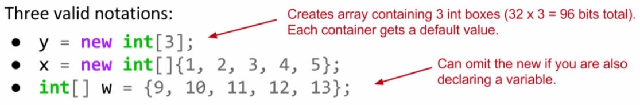

All three notations create an array. The first notation, used to create x, will create an array of the specified length and fill in each memory box with a default value. In this case, it will create an array of length 3, and fill each of the 3 boxes with the default int value 0.

The second notation, used to create y, creates an array with the exact size needed to accommodate the specified starting values. In this case, it creates an array of length 5, with those five specific elements.

The third notation, used to declare and create z, has the same behavior as the second notation. The only difference is that it omits the usage of new, and can only be used when combined with a variable declaration.

None of these notations is better than any other.

### Instantiation of Arrays (CS 61B)

Variables that store arrays are reference variables just like any other. As an example, consider the declarations below:

int[] x;

Planet[] planets;

Both of these declarations create memory boxes of 64 bits. x can only hold the address of an int array, and planets can only hold the address of a Planet array. Instantiating an array is very similar to instantiating an object. For example, if we create an integer array of size 5 as shown below:

x = new int[]{0, 1, 2, 95, 4};

Then the new keyword creates 5 boxes of 32 bits each and returns the address of the overall object for assignment to x.

### System.arraycopy(); (CS 61B)

Using System.arraycopy() is a way to copy information from one array to another. System.arraycopy takes five parameters:

1. The array to use as a source
2. Where to start in the source array
3. The array to use as a destination
4. Where to start in the destination array
5. How many items to copy

An alternate approach to copying arrays would be to use a loop. arraycopy is usually faster than a loop, and results in more compact code. The only downside is that arraycopy is (arguably) harder to read.

### 2D Arrays in Java (CS 61B)

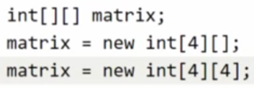

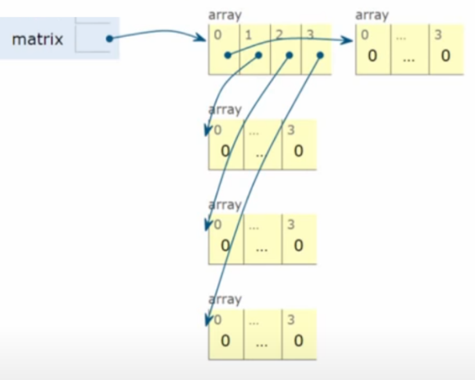



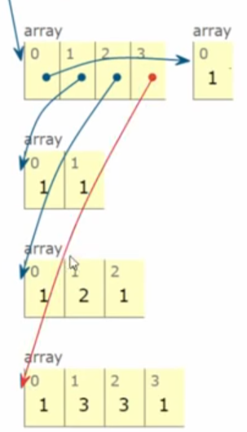

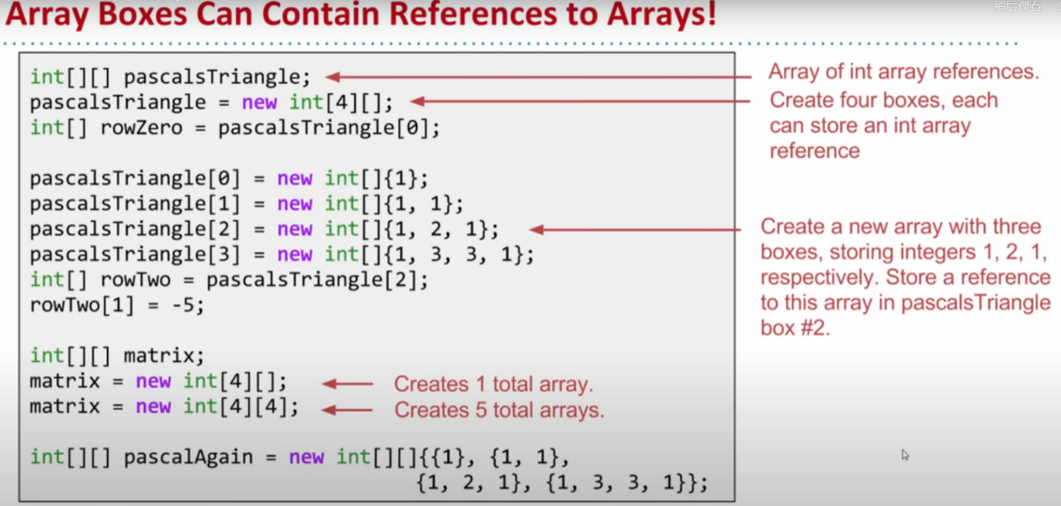

### Arrays VS Classes (CS 61B)

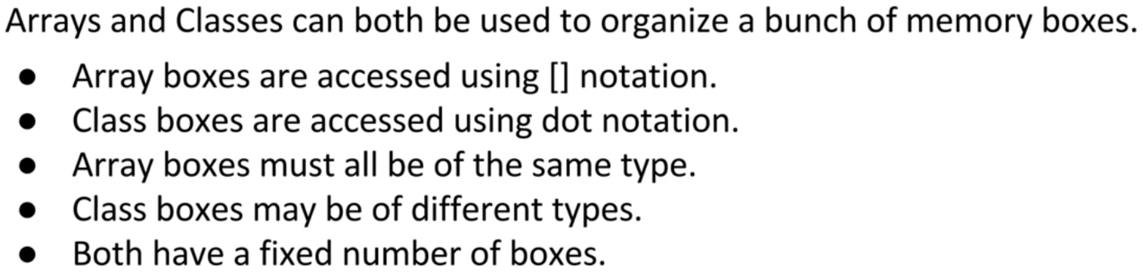

Both arrays and classes can be used to organize a bunch of memory boxes. In both cases, the number of memory boxes is fixed, i.e. the length of an array cannot be changed, just as class fields cannot be added or removed.

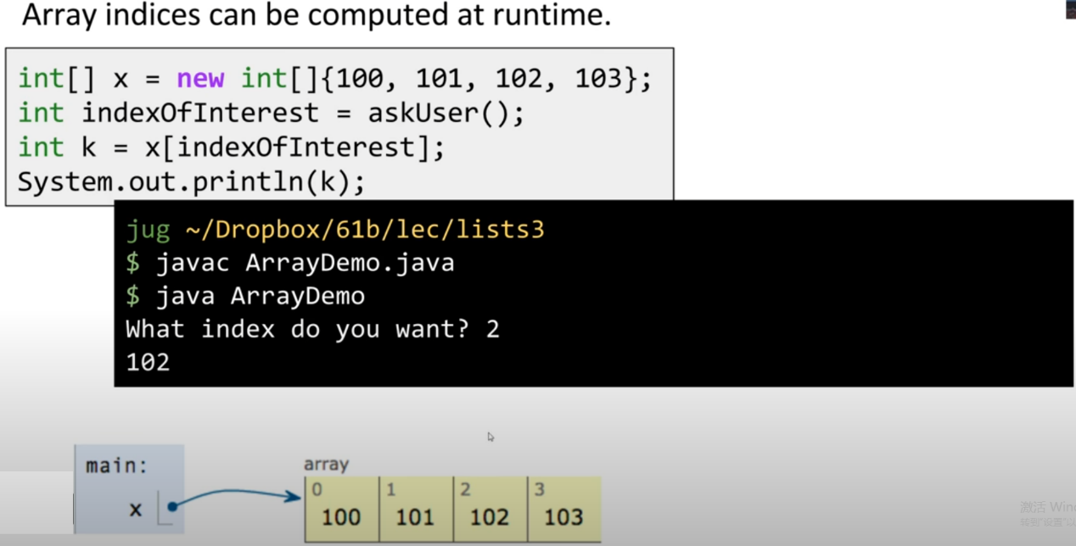



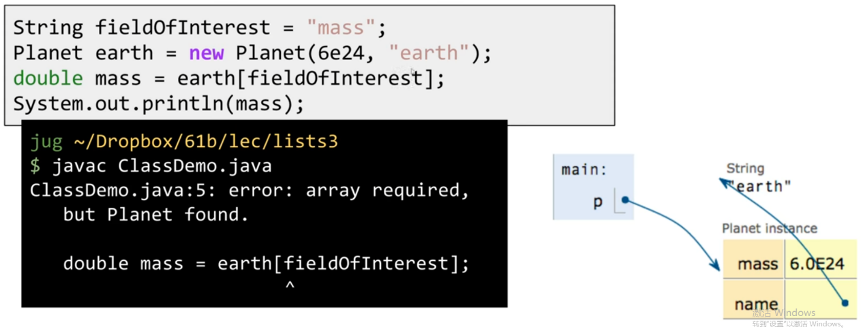

The only (easy) way to access a member of a class is with hard-code dot notation.

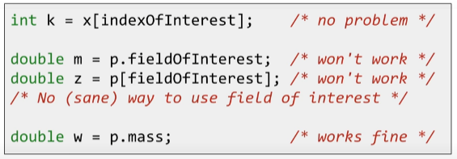



## Chapter 4 Methods Use Instance Variables

We refer to the entire string public static int max(int x, int y) as the method’s **signature**, as it lists the parameters, return type, name, and any modifiers.

### parameter VS argument

A method uses parameters.

A caller passes arguments.

### void method

If a method is made with a void return type, it does not give anything back.

### method returning a specific type

If you declare a method to return a value, you must return a value of the declared type! (Or a value that is compatible with the declared type.)





### arguments

If a method has parameters, you must pass arguments of the right type and order.









### Java is pass-by-value

Java is pass-by-value. This means pass-by-copy.









It is the same if the argument you want to pass is an object (actually, it should be a reference to an object) instead of a primitive. Java passes everything by value. If you pass a reference to an object into a method, you are passing a copy of the remote control.

### Parameter Passing (CS 61B)

When you pass parameters to a function, you are also simply copying the bits. In other words, the GRoE also applies to parameter passing. Copying the bits is usually called "pass by value". In Java, we always pass by value.

For example, consider the function below:

public static double average(double a, double b) {

return (a + b) / 2;

}

Suppose we invoke this function as shown below:

public static void main(String[] args) {

double x = 5.5;

double y = 10.5;

double avg = average(x, y);

}

After executing the first two lines of this function, the main method will have two boxes labeled x and y containing the values shown below:



When the function is invoked, the average function has its **own** scope with two new boxes labeled as a and b, and the bits are simply copied in. This copying of bits is what we refer to when we say "pass by value".



If the average function were to change a, then x in main would be unchanged, since the GRoE tells us that we'd simply be filling in the box labeled a with new bits.

### a method declaring multiple return values

A method can declare only one return value. If you want to return, say, three int values, then the declared return type can be an int array. Stuff those ints into the array, and pass it on back.

### Do I have to return the exact type I declared?

You can return anything that can be implicitly promoted to that type. So, you can pass a byte where an int is expected.

When the declared type is smaller than what you’re trying to return you must use an explicit cast.

Same thing with parameters.

### Do I have to do something with the return value of a method?

You can ignore the return value of a method.

### getters and setters

Getters and Setters (Accessors and Mutators) let you, well, get and set things. Instance variable values, usually.

### hide the data

Mark instance variables private.

Mark getters and setters public.



### Instance variables get a default value.

Instance variables always get a default value. If you don’t explicitly assign a value to an instance variable, or you don’t call a setter method, the instance variable still has a value!



### Local variables do not get a default value.





### method parameters – initialized?

Method parameters are virtually the same as local variables—they’re declared inside the method (well, technically they’re declared in the argument list of the method rather than within the body of the method, but they’re still local variables as opposed to instance variables).

But method parameters will never be uninitialized, so you’ll never get a compiler error telling you that a parameter variable might not have been initialized. But that’s because the compiler will give you an error if you try to invoke a method without sending arguments that the method needs.

So parameters are ALWAYS initialized, because the compiler guarantees that methods are always called with arguments that match the parameters declared for the method, and the arguments are assigned (automatically) to the parameters.

### comparing variables (primitives and references)

Use == to compare two primitives, or to see if two references refer to the same object.

Use the equals() method to see if two different objects are equal.

The == operator is used only to compare the bits in two variables. What those bits represent doesn’t matter. The bits are either the same, or they’re not.



## Chapter 5 Writing a Programme

### developing a class

1. Figure out what the class is supposed to do.
2. List the instance variables and methods.
3. Write prepcode for the methods.
4. Write test code for the methods.
5. Implement the class.
6. Test the methods.
7. Debug and reimplement as needed.
8. Express gratitude that we don’t have to test our so-called learning experience app on actual live users.





Most prepcode includes three parts: instance variable declarations, method declarations, method logic.





### Extreme Programming (XP)

Considered by many to be “the way programmers really want to work”, XP emerged in the late 90’s and has been adopted by many companies. The thrust of XP is that the customer gets what he wants, when he wants it, even when the spec changes late in the game.

* Keep it simple.
* Don’t put in anything that’s not in the spec (no matter how tempted you are to put in functionality “for the future”).
* Develop in iteration cycles.
* Make small, but frequent, releases.
* Set realistic schedules, based around small releases.
* No killer schedules; work regular hours.
* Write the test code first.
* Don’t release anything until it passes all the tests.
* Refactor (improve the code) whenever and wherever you notice the opportunity.
* Program in pairs, and move people around so that everybody knows pretty much everything about the code.

### Integer.parseInt()

Integer.parseInt() works only on Strings that represent the ascii values for digits (0,1,2,3,4,5,6,7,8,9). If you try to parse something like “two” or “blurp”, the code will blow up at runtime. (By blow up, we actually mean throw an exception, but we don’t talk about exceptions until the Exceptions chapter. So for now, blow up is close enough.)

### two different styles of for loops

From the first version of Java there has been a single kind of for loop that looks like this:

for (int i = 0; i < 10; i++) {

// do something 10 times

}

You can use this format for any kind of loop you need.

But... beginning with Java 5.0 (Tiger), you can also use the enhanced for loop when your loop needs to iterate over the elements in an array (or another kind of collection).

You can always use the plain old for loop to iterate over an array, but the enhanced for loop makes it easier.





### for loops VS while loops

Choose for loops over while loops when you know how many times you want to repeat the loop code.

### ++x VS x++

Putting the operator before the variable (for example, ++x), means, “first, increment x by 1, and then use this new value of x.” This only matters when the ++x is part of some larger expression rather than just in a single statement.

int x = 0; int z = ++x;

produces: x is 1, z is 1

But putting the ++ after the x give you a different result:

int x = 0; int z = x++;

produces: x is 1, but z is 0!

z gets the value of x and then x is incremented.

### casting primitives

You can’t shove a big thing directly into a small thing.



To force the compiler to jam the value of a bigger primitive variable into a smaller one, you can use the cast operator. It looks like this:



And let’s say you have a floating point number, and you just want to get at the whole number (int) part of it:



## Chapter 6 Get to Know The Java API

The Java library is known as the Java API.

The core Java library is a giant pile of classes just waiting for you to use like building blocks.

A Java API/ library includes packages. A package includes classes(Classes are grouped into packages.).

A package is a collection of Java classes that all work together towards some common goal.

For example, org.junit is a package that contains various classes useful for testing, including our familiar Assert class, which contains useful static methods like assertEquals. In other words, when we saw org.junit.Assert.assertEquals, the org.junit was the package name, Assert was the class name, and assertEquals was the method name. We call org.junit.Assert.assertEquals the “canonical name” of the method, and we call assertEquals the “simple name” of the method.



### Short Circuit Operators ( && , || )

The operators we’ve looked at so far, && and ||, are known as short circuit operators.

In the case of &&, the expression will be true only if both sides of the && are true. So if the JVM sees that the left side of a && expression is false, it stops right there! Doesn’t even bother to look at the right side.

Similarly, with ||, the expression will be true if either side is true, so if the JVM sees that the left side is true, it declares the entire statement to be true and doesn’t bother to check the right side.

### Non Short Circuit Operators ( & , | )

When used in boolean expressions, the & and | operators act like their && and || counterparts, except that they **force the JVM to always check both sides of the expression**. Typically, & and | are used in another context, for manipulating bits.

### full name of the class

You have to indicate the full name of the library class you want to use, and that means package name + class name.



You have to know the full name* of the class you want to use in your code. Unless the class is in the java.lang package.

The class java.lang is the one you don’t have to import.





### purposes of a package

First, they help the **overall organization** of a project or library. Rather than just having one horrendously large pile of classes, they’re all grouped into packages for specific kinds of functionality (like GUI, or data structures, or database stuff, etc.)

Second, packages give you **a name-scoping**, to help prevent collisions if you and 12 other programmers in your company all decide to make a class with the same name.

Third, packages provide a level of **security**, because you can restrict the code you write so that only other classes in the same package can access it.

### when a package starts with javax

Packages in the standard library don’t have that “x”, and only extensions have the “x”. These classes which were known as extensions were other packages not included in the standard library.

The mother of all standard extensions was the Swing library. It included several packages, all of which began with javax.swing.

When you see a package in the library that begins with javax, you know it started life as an extension, and then got a promotion (to become a part of a standard library).

(同一級別：The Java library is known as the Java API. an extension)

### declare the type of the array

You declare the type of the array using a type parameter, which is **a type name in angle brackets**.

Example: ArrayList<Button> means the ArrayList will be able to hold only objects of type Button (or subclasses of Button as you’ll learn in the next couple of chapters)

### an ArrayList wrapping and unwrapping primitives

Although an ArrayList holds objects and not primitives, the compiler will automatically “wrap” (and “unwrap” when you take it out) a primitive into an Object, and place that object in the ArrayList instead of the primitive.

## Chapter 7 Inheritance and Polymorphism

### Basic use of extends (CS 61B)

By using the extends keyword, subclasses inherit all **members** of the parent class. "Members" includes:

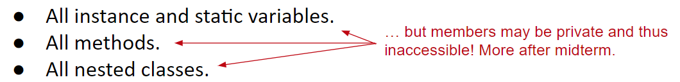

Note that constructors are not inherited, and private members cannot be directly accessed by subclasses.

### Constructors Are Not Inherited (CS 61B)

While constructors are not inherited, Java requires that **all constructors must start with a call to one of its superclass's constructors**.

To gain some intuition on why that it is, recall that the extends keywords defines an "is-a" relationship between a subclass and a parent class. If a VengefulSLList "is-an" SLList, then it follows that every VengefulSLList must be set up like an SLList.

Here's a more in-depth explanation. Let's say we have two classes:

public class Human {...}

public class TA extends Human {...}

It is logical for TA to extend Human, because all TA's are Human. Thus, we want TA's to inherit the attributes and behaviors of Humans.

If we run the code below:

TA Christine = new TA();

Then first, a Human must be created. Then, that Human can be given the qualities of a TA. It doesn't make sense for a TA to be constructed without first creating a Human first.

Thus, we can either explicitly make a call to the superclass's constructor, using the super keyword:

public VengefulSLList() {

super();

deletedItems = new SLList<Item>();

}

Or, if we choose not to, Java will automatically make a call to the superclass's no-argument constructor for us.

In this case, adding super() has no difference from the constructor we wrote before. It just makes explicit what was done implicitly by Java before.

### constructor with argument (CS 61B)

If you want to use a super constructor other than the no-argument constructor, can give parameters to super.

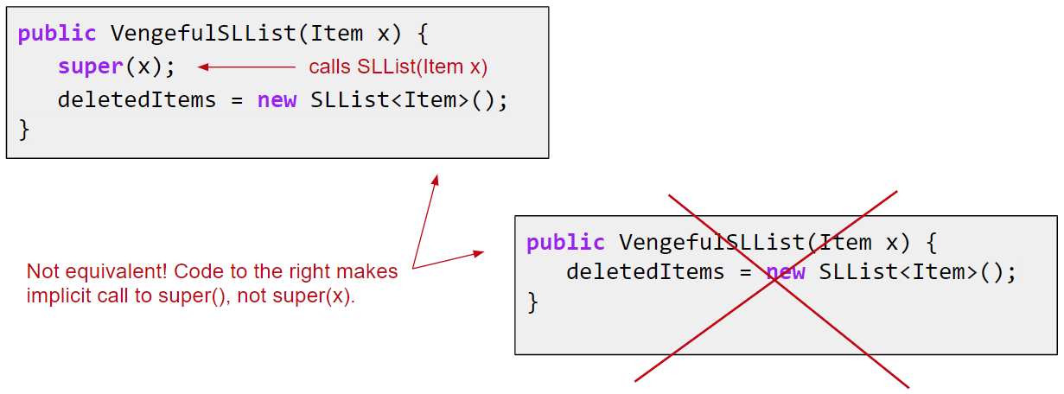

### add and override

A subclass can **add new methods and instance variables** of its own, and it can **override** the **methods** it inherits from the superclass.

Instance variables are not overridden because they don’t need to be. They don’t define any special behavior, so a subclass can give an inherited instance variable any value it chooses.

If a subclass has a method with the exact same signature as in the superclass, we say **the subclass overrides the method.**

* Even if you don’t write @Override, subclass still overrides the method.
* @Override is just an optional reminder that you are overriding.

  @Override

  public EType getFirst() {

    return items[0];

  }

Why use @Override?

* Main reason: Protects against typos.
  + If you say @Override, but the method isn’t actually overriding anything, you will get a compile error.
  + E.g. public void addLats(Item x) (This is wrong.)
* Reminds programmer that method definition came from somewhere higher up in the inheritance hierarchy.

### using is-a

When one class **inherits from** another, we say that the subclass **extends** the superclass. When you want to know if one thing should extend another, apply the **IS-A** test. Triangle IS-A Shape, yeah, that works. Cat IS-A Feline, that works too. Surgeon IS-A Doctor, still good.

This is true anywhere in the inheritance tree. If class C extends class B, class C passes the IS-A test for both B and A.



Inheritance IS-A relationship works in only one direction! Triangle IS-A Shape makes sense, so you can have Triangle extend Shape. But the reverse—Shape IS-A Triangle—does not make sense.

### using has-a

Tub IS-A Bathroom is definitely false. Bathroom IS-A Tub doesn’t work either. Tub and Bathroom are related, but not through inheritance. Tub and Bathroom are joined by a HAS-A relationship.



### use BOTH the superclass version and my overriding subclass version of a method



### the level of access

A superclass can choose whether or not it wants a subclass to inherit a particular member by the level of access the particular member is given. There are four access levels that we’ll cover in this book. Moving from most restrictive to least, the four access levels are:



Access levels control who sees what.



### when a subclass inherits a member

When a subclass inherits a member, it is **as if the subclass defined the member itself**.

In the Shape example, Square inherited the rotate() and playSound() methods and to the outside world (other code) the Square class simply has a rotate() and playSound() method.

The members of a class include the variables and methods **defined** in the class plus anything **inherited** from a superclass.

### polymorphism

Before we learn polymorphism, we know that:

Dog myDog = new Dog();



With polymorphism, the reference type can be a superclass of the actual object type.



Another example of polymorphism:



————————————





Polymorphism: What you want is the ability to use a superclass type (often abstract) as a method argument, return type, or array type.

### Are there any practical limits on the levels of subclassing? How deep can you go?

If you look in the Java API, you’ll see that most inheritance hierarchies are wide but not deep. Most are no more than one or two levels deep, although there are exceptions (especially in the GUI classes). You’ll come to realize that it usually makes more sense to keep your inheritance trees shallow, but there isn’t a hard limit (well, not one that you’d ever run into).

### If you don’t have access to the source code for a class, but you want to change the way a method of that class works, could you use subclassing to do that? To extend the “bad” class and override the method with your own better code?

Yep. That’s one cool feature of OO, and sometimes it saves you from having to rewrite the class from scratch, or track down the programmer who hid the source code.

### a class cannot be subclassed

There’s no such thing as a private class, except in a very special case called an inner class, that we haven’t looked at yet.

But there are three things that can prevent a class from being subclassed.

The first is access control. Even though a class can’t be marked private, a class can be non-public (what you get if you don’t declare the class as public). A non-public class can be subclassed only by classes in the same package as the class. Classes in a different package won’t be able to subclass (or even use, for that matter) the non-public class.

The second thing that stops a class from being subclassed is the keyword modifier final. A final class means that it’s the end of the inheritance line. Nobody, ever, can extend a final class.

The third issue is that if a class has only private constructors (we’ll look at constructors in chapter 9), it can’t be subclassed.

### why making a final class?

Typically, you won’t make your classes final. But if you need security — the security of knowing that the methods will always work the way that you wrote them (because they can’t be overridden), a final class will give you that. A lot of classes in the Java API are final for that reason. The String class, for example, is final because, well, imagine the havoc if somebody came along and changed the way Strings behave!

### Can you make a method final, without making the whole class final?

If you want to protect a specific method from being overridden, mark the method with the final modifier. Mark the whole class as final if you want to guarantee that none of the methods in that class will ever be overridden.

### rules for overriding

**The methods *are* the contract.**

① The arguments and return types of your overriding method must look to the outside world exactly like the overridden method in the superclass.

Arguments must be the same, and return types must be compatible.

Whatever the superclass declares as a return type, the overriding method must declare either the same type, or a subclass type.

② The method can’t be less accessible. That means the access level must be the same, or friendlier. That means you can’t, for example, override a public method and make it private.



### overloading a method

Method overloading is nothing more than having two methods with the **same name** but **different argument lists**.



The return types can be different.

You can’t change ONLY the return type.

You can vary the access levels in any direction.

### Overloaded methods (CS 61B)

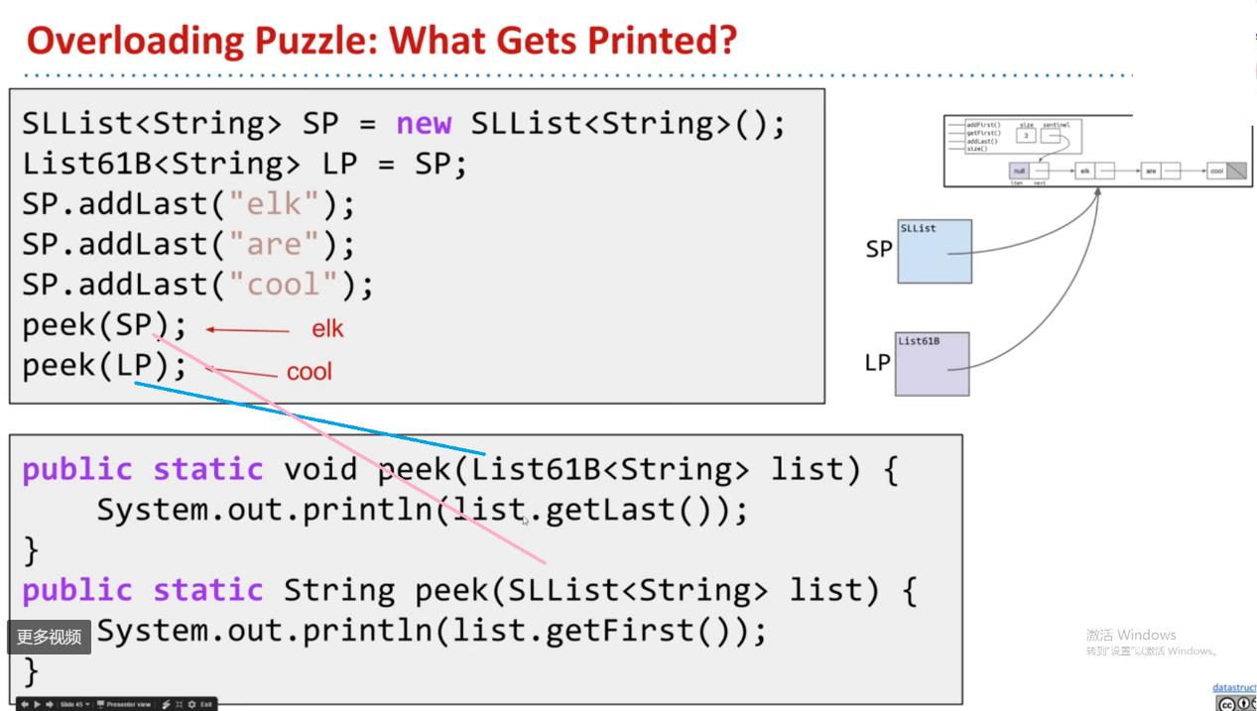

### Encapsulation (CS 61B)

Encapsulation is one of the fundamental principles of object-oriented programming, and is one of the approaches that we take as programmers to resist our biggest enemy: complexity. Managing complexity is one of the major challenges we must face when writing large programs.

Some tools for managing complexity:

* Hierarchical abstraction.
  + Create **layers of abstraction**, with clear abstraction barriers!
  + Abstraction Barriers
    - Ideally, a user should not be able to observe the internal workings of, say, a data structure they are using. Fortunately, Java makes it easy to enforce abstraction barriers. Using the private keyword in Java, it becomes virtually impossible to look inside an object - ensuring that the underlying complexity isn't exposed to the outside world.
* “Design for change” (D. Parnas)
  + Organize program around objects.
  + Let objects decide how things are done.
  + **Hide information** others don’t need.

The root of encapsulation lies in this notion of hiding information from the outside. One way to look at it is to see how encapsulation is analogous to a Human cell. The internals of a cell may be extremely complex, consisting of chromosomes, mitochondria, ribosomes etc., but yet it is fully encapsulated into a single module - abstracting away the complexity inside.

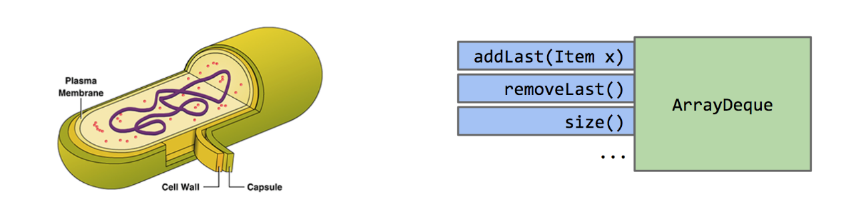

In computer science terms, a module can be defined as a set of methods that work together as a whole to perform a task or set of related tasks. This could be something like a class that represents a list. Now, **if the implementation details of a module are kept internally hidden and the only way to interact with it is through a documented interface, then that module is said to be encapsulated.**

Take the ArrayDeque class, for example. The outside world is able to utilize and interact with an ArrayDeque through its defined methods, like addLast and removeLast. However, they need not understand the complex details of how the data structure was implemented in order to be able to use it effectively.

## Chapter 8 Interfaces and Abstract Classes

### default method in interface (CS 61B)

如果interface里面有个已经实现了的method（method以default开头），subclass可以直接用这个method，也可以implement这个method并改写成自己需要的样子。

例子，Superclass 里面的method：

  default public void print() { // Remember to write default. Everything that implements the List61B class can use this print() method, as long as they do not override print().

    for (int i = 0; i < size(); i++) {

      System.out.print(get(i) + " "); // get has to seek all the way to the given item for SLists, so it is not efficient for an SLList. Therefore, the SLList has to override it to make it more efficient. But this is efficient for an AList, so an AList does not have to override print().

    }

    System.out.println("");

  }

如果subclass不用这个default print()，而是override it，这就是interface inheritance。

如果subclass用这个default print()，这就是implementation inheritance。

### Static Type vs. Dynamic Type (CS 61B)

Every variable in Java has a “compile-time type”, a.k.a. “static type”.

* This is the type specified at **declaration**. Never changes!

Variables also have a “run-time type”, a.k.a. “dynamic type”.

* This is the type specified at **instantiation** (e.g. when using new).
* Equal to the type of the object being pointed at.

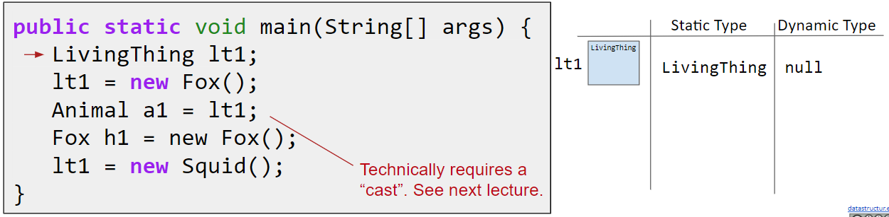

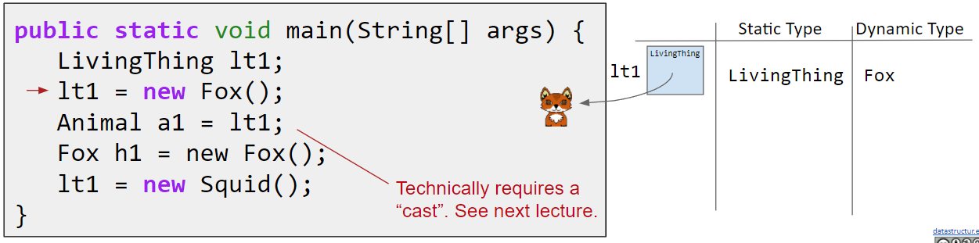

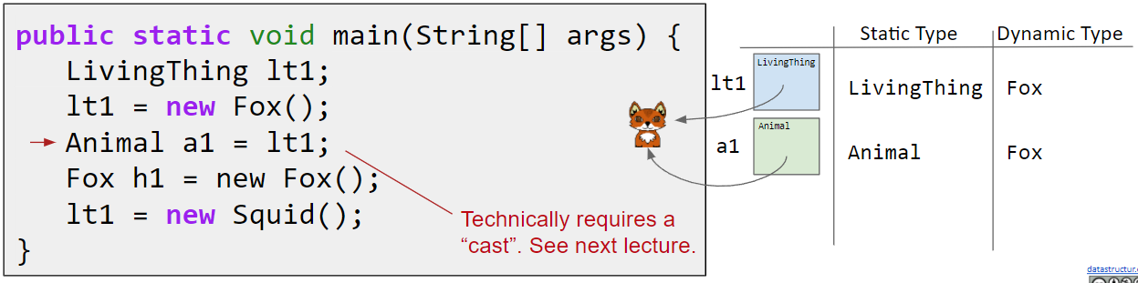

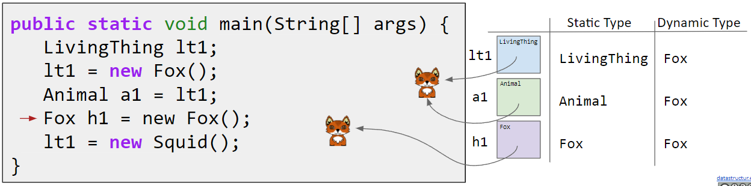

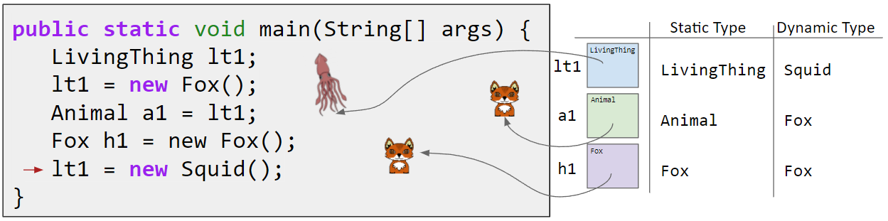

Suppose we call a method of an object using a variable with:

* compile-time type X
* run-time type Y

Then if Y **overrides** the method, Y’s method is used instead.

* This is known as “dynamic method selection”.

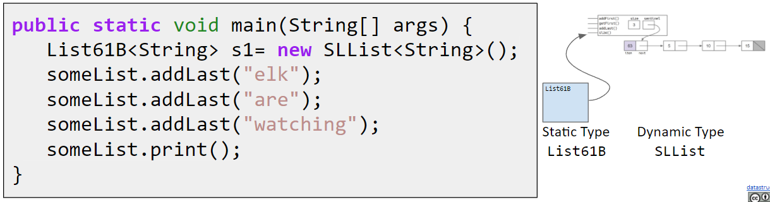

IMPORTANT: This(“dynamic method selection”) does not work for overloaded methods!

* Compiler allows the memory box to hold any subtype.
* Compiler allows calls based on static type.
* Overriden non-static methods are selected at **runtime** based on dynamic type.
* For overloaded methods, the method is selected at **compile time**.

### Dynamic Method Selection Puzzle (CS 61B)

講解地址

<https://www.youtube.com/watch?v=OMaWI41pcxo&list=PL8FaHk7qbOD7Ycy9QeJSPXVoTwAH52Rlw&index=11>

When Java checks to see which method to call, it checks the **static type** and calls the method with the parameter of the same type.

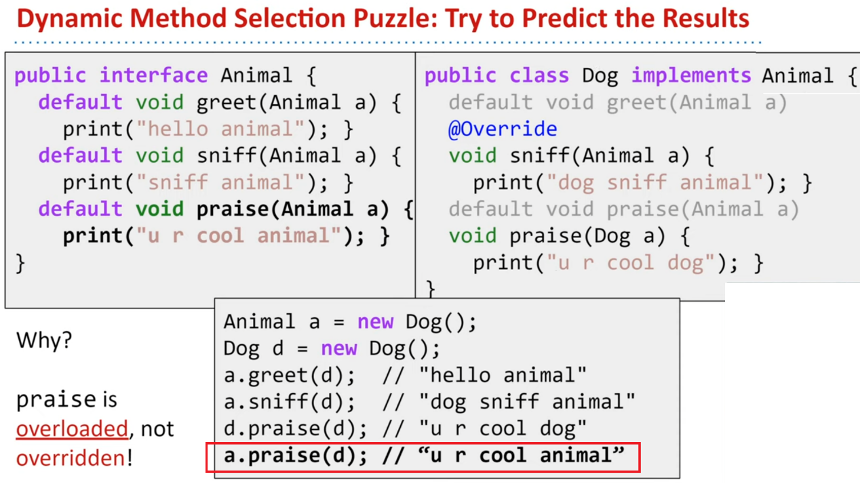

Another way to think about dynamic method selection is as a 2 step process, where step 1 happens at compile time, and step 2 happens at runtime.

These two steps obey rules that are easy to apply, but take time to understand.

* At compile time: We determine the **signature S** of the method to be called.
  + S is decided using **ONLY static types**.
* At runtime: The dynamic type of the **invoking object** uses its method with this exact signature S.
  + By “invoking object”, we mean the object whose method is invoked.

The signature is the method name and the number and type of its parameters.

Step one:

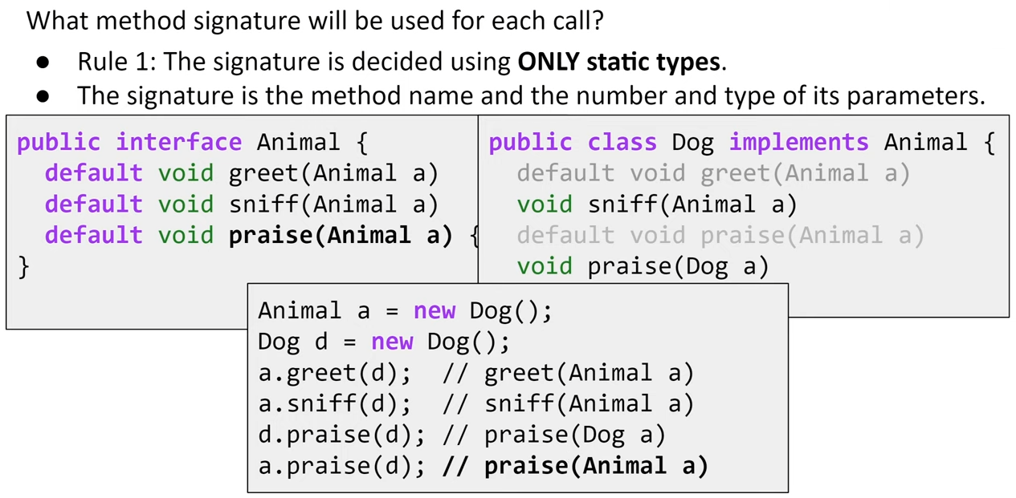

Step two:

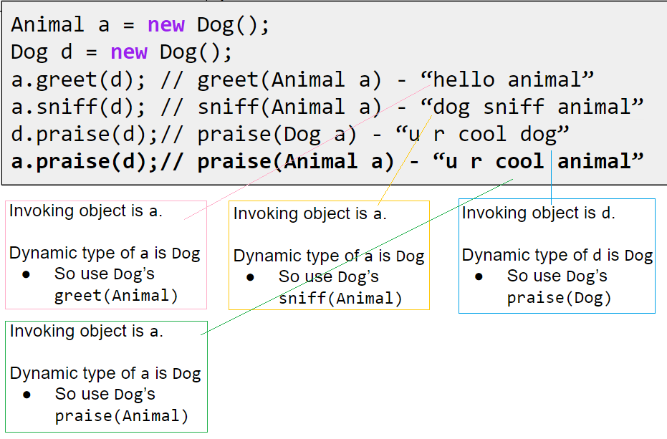

### calling the most specific version of the method

When you call a method on an object reference, you’re calling the most specific version of the method for that object type. In other words, the lowest one wins! “Lowest” meaning lowest on the inheritance tree. Canine is lower than Animal, and Wolf is lower than Canine, so invoking a method on a reference to a Wolf object means the JVM starts looking first in the Wolf class. If the JVM doesn’t find a version of the method in the Wolf class, it starts walking back up the inheritance hierarchy until it finds a match.



### abstract classes

We need an Animal class, for inheritance and polymorphism. But we want programmers to instantiate only the less abstract subclasses of class Animal, not Animal itself. We want Tiger objects and Lion objects, not Animal objects.

By marking the class as abstract, the compiler will stop any code, anywhere, from ever creating an instance of that type.



An **abstract class** has virtually* no use, no value, no purpose in life, unless it is **extended**.

(*There is an exception to this—an abstract class can have **static members** (see chapter 10).)



### abstract methods

An **abstract class** means the class must be **extended**; an **abstract method** means the method must be **overridden**.

An abstract method has no body!



If you declare an abstract method, you MUST mark the class abstract as well. You can’t have an abstract method in a non-abstract class. If a class has even one abstract method, the class must be marked abstract.

You can mix both abstract and nonabstract methods in the abstract class.

### You MUST implement all abstract methods

When we say “you must implement the abstract method”, that means you must **provide a body**. That means you must create a non-abstract method in your class with the same method signature (name and arguments) and a return type that is compatible with the declared return type of the abstract method. What you put in that method is up to you. All Java cares about is that the method is there, in your concrete subclass.

Implementing an abstract method is just like overriding a method.

Abstract methods don’t have a body; they exist solely for polymorphism. That means **the first concrete class in the inheritance tree must implement all abstract methods**.

### Every class in Java extends class Object ((java.lang.Object).

Object is a non-abstract class because it’s got method implementation code that all classes can inherit and use out-of-the-box, without having to override the methods.

Sometimes you just want a generic object to use as, well, as an object. A lightweight object. By far, the most common use of an instance of type Object is for thread synchronization (which you’ll learn about in chapter 15). For now, just stick that on the back burner and assume that you will rarely make objects of type Object, even though you can.

You can override some of the methods in Object. But some of them are marked final, which means you can’t override them. You’re encouraged (strongly) to override hashCode(), equals(), and toString() in your own classes.

ArrayList<DotCom> means I was restricting the ArrayList to hold only DotCom objects. Prior to Java 5.0, ArrayLists couldn’t be restricted. They were all essentially what you get in Java 5.0 today if you write ArrayList<Object>.

### The Object class serves two main purposes.

1. to act as a polymorphic type for methods that need to work on any class that you or anyone else makes,

2. and to provide real method code that all objects in Java need at runtime (and putting them in class Object means all other classes inherit them).

Some of the most important methods in Object are related to threads, and we’ll see those later in the book.

### Using polymorphic references of type Object has a price...

When you put an object into an ArrayList<Dog>, it goes in as a Dog, and comes out as a Dog:



When you declare it as ArrayList<Object>, it goes in as a Dog, and comes out as an Object:







————————————







### Objects don’t bark.







Just remember that the compiler checks the class of the reference variable, not the class of the actual object at the other end of the reference.

You can call methods on an object only if the methods are in the **class (or interface)** used as the reference variable type, regardless of the actual object type.

### The Object Class (CS 61B)

Every class in Java is a descendant of the Object class, or extends the Object class. Even classes that do not have an explicit extends in their class still implicitly extend the Object class.

For example,

* VengefulSLList extends SLList explicitly in its class declaration
* SLList extends Object implicitly

This means that since SLList inherits all members of Object, VengefulSLList inherits all members of SLList and Object, transitively. So, what is to be inherited from Object?

As seen in the [documentation for the Object class](https://docs.oracle.com/javase/8/docs/api/java/lang/Object.html), the Object class provides operations that every Object should be able to do - like .equals(Object obj), .hashCode(), and toString().

Interfaces don’t extend Object.

### objects are Objects

When you say new Snowboard(), you get a single object on the heap—a Snowboard object—but that Snowboard wraps itself around an inner core representing the Object (capital “O”) portion of itself.



### put an object in VS get a reference from an ArrayList<Object>

When you put an object in an ArrayList<Object>, you can treat it only as an Object, regardless of the type it was when you put it in.

When you get a reference from an ArrayList<Object>, the reference is always of type Object. That means you get an Object remote control.

### ‘Polymorphism’ means ‘many forms’.

You can treat a Snowboard as a Snowboard or as an Object.

If a reference is like a remote control, the remote control takes on more and more buttons as you move down the inheritance tree. A remote control (reference) of type Object has only a few buttons—the buttons for the exposed methods of class Object. But a remote control of type Snowboard includes all the buttons from class Object, plus any new buttons (for new methods) of class Snowboard. The more specific the class, the more buttons it may have.

Of course, that’s not always true; a subclass might not add any new methods, but simply override the methods of its superclass. The key point is that even if the object is of type Snowboard, an Object reference to the Snowboard object can’t see the Snowboard-specific methods.



### casting objects: Casting an object reference back to its real type.

Essentially, casting is telling the compiler not to do its type-checking duties - telling it to trust you and act the way you want it to.



It’s really still a Dog object, but if you want to call Dog-specific methods, you need a reference declared as type Dog. If you’re sure* the object is really a Dog, you can make a new Dog reference to it by copying the Object reference, and forcing that copy to go into a Dog reference variable, using a cast (Dog). You can use the new Dog reference to call Dog methods.



*If you’re not sure it’s a Dog, you can use the **instanceof** operator to check. Because if you’re wrong when you do the cast, you’ll get a ClassCastException at runtime and come to a grinding halt.



**Question:** ArrayList<Dog> gives back Dog references that don’t need to be cast, yet the ArrayList class uses Object in its methods, not Dog (or DotCom or anything else). What’s the special trick going on when you say ArrayList<Dog>?

**Answer:** In fact it is a special trick that ArrayList<Dog> gives back Dogs without you having to do any cast, since it looks like ArrayList methods don’t know anything about Dogs, or any type besides Object.

The short answer is that the compiler puts in the cast for you! When you say ArrayList<Dog>, there is no special class that has methods to take and return Dog objects, but instead the <Dog> is a signal to the compiler that you want the compiler to let you put ONLY Dog objects in and to stop you if you try to add any other type to the list. And since the compiler stops you from adding anything but Dogs to the ArrayList, the compiler also knows that it’s safe to cast anything that comes out of that ArrayList to a Dog reference. In other words, using ArrayList<Dog> saves you from having to cast the Dog you get back. But it’s much more important than that... because remember, a cast can fail at runtime, and wouldn’t you rather have your errors happen at compile time rather than, say, when your customer is using it for something critical?

But there’s a lot more to this story, and we’ll get into all the details in the Collections chapter.

### casting can be dangerous (CS 61B)

Caution: Casting is a powerful but dangerous tool. Here's a possible issue that could arise:

Poodle frank = new Poodle("Frank", 5);

Malamute frankSr = new Malamute("Frank Sr.", 100);

Poodle largerPoodle = (Poodle) maxDog(frank, frankSr); // runtime exception!

In this case, we compare a Poodle and a Malamute. Without casting, the compiler would normally not allow the call to maxDog to compile, as the right hand side compile-time type would be Dog, not Poodle. However, casting allows this code to pass, and when maxDog returns the Malamute at runtime, and we try casting a Malamute as a Poodle, we run into a runtime exception - a ClassCastException.

### Multiple inheritance is not allowed in Java



Multiple inheritance has a problem known as The Deadly Diamond of Death, so multiple inheritance is not possible to do in Java. That means you can extend only one class (i.e. you can have only one immediate superclass).



### interfaces

A Java interface solves your multiple inheritance problem by giving you much of the polymorphic benefits of multiple inheritance without the pain and suffering from the Deadly Diamond of Death (DDD).

An interface is like a 100% pure abstract class. It defines only abstract methods.

The way in which interfaces side-step the DDD is surprisingly simple: **make all the methods abstract**! That way, the subclass must implement the methods (remember, abstract methods must be implemented by the first concrete subclass), so at runtime the JVM isn’t confused about which of the two inherited versions it’s supposed to call.







A class that implements an interface must **implement all the methods of the interface**, since all interface methods are implicitly public and abstract.

### Making and Implementing the Pet interface



### Classes from different inheritance trees can implement the same interface.



### when you use an interface as a polymorphic type

When you use a class as a polymorphic type (like an array of type Animal or a method that takes a Canine argument), the objects you can stick in that type must be **from the same inheritance tree**. But not just anywhere in the inheritance tree; the objects must be from a class that is **a subclass** of the polymorphic type. An argument of type Canine can accept a Wolf and a Dog, but not a Cat or a Hippo.

But when you use an interface as a polymorphic type (like an array of Pets), the objects can be **from anywhere in the inheritance tree**. The only requirement is that the objects are from a class that **implements the interface**.

Allowing classes in different inheritance trees to implement a common interface is crucial in the Java API. Do you want an object to be able to save its state to a file? Implement the Serializable interface. Do you need objects to run their methods in a separate thread of execution? Implement Runnable. You get the idea. You’ll learn more about Serializable and Runnable in later chapters, but for now, remember that classes from any place in the inheritance tree might need to implement those interfaces. Nearly any class might want to be saveable or runnable.

### a class can implement multiple interfaces

A Dog object IS-A Canine, and IS-A Animal, and IS-A Object, all through inheritance.

A Dog IS-A Pet through interface implementation, and the Dog might implement other interfaces as well. You could say:



### How do you know whether to make a class, a subclass, an abstract class, or an interface?

* Make a class that **doesn’t extend anything** (other than Object) when your new class doesn’t pass the IS-A test for any other type.
* Make a subclass (in other words, extend a class) only when you need to make a **more specific** version of a class and need to override or add new behaviours.
* Use an abstract class when you want to define a **template** for a group of subclasses, and you have at least some implementation code that all subclasses could use. Make the class abstract when you want to guarantee that nobody can make objects of that type.
* Use an interface when you want to define a **role** that other classes can play, regardless of where those classes are in the inheritance tree.

### Invoking the superclass version of a method

super.method()





## Chapter 9 Life and Death of an Object

### the stack and the heap

Java has two areas of memory we care about: the Stack and the Heap.



### instance variables VS local variables



### Methods are stacked



When you call a method, the method lands on the top of a call stack. That new thing that’s actually pushed onto the stack is the **stack frame**, and it holds the state of the method including which line of code is executing, and the values of all local variables.

A method stays on the stack until the method hits its closing curly brace (which means the method’s done). If method foo() calls method bar(), method bar() is stacked on top of method foo().



### object references on the stack

If the local variable is a reference to an object, only the variable (the reference/remote control) goes on the stack. The object itself still goes in the heap.



Object reference variables work just like primitive variables—if the reference is declared as a local variable, it goes on the stack.

All objects live in the heap, regardless of whether the reference is a local or instance variable.

### Where do instance variables live?



If the instance variables are all primitives, Java makes space for the instance variables based on the primitive type.

If CellPhone has an instance variable declared as the non-primitive type Antenna, Java makes space within the CellPhone object only for the Antenna’s remote control (i.e. reference variable) but not the Antenna object.



If the instance variable is declared but no object is assigned to it, then only the space for the reference variable (the remote control) is created.

**private Antenna ant;**

No actual Antenna object is made on the heap unless or until the reference variable is assigned a new Antenna object.

**private Antenna ant = new Antenna();**

### the miracle of object creation



A constructor has the code that runs when you instantiate an object. In other words, the code that runs when you say new on a class type. Every class you create has a constructor, even if you don’t write it yourself.

A constructor must have the same name as the class, and must not have a return type.

The only way to invoke a constructor is with the keyword new followed by the class name. The JVM finds that class and invokes the constructor in that class. (OK, technically this isn’t the only way to invoke a constructor. But it’s the only way to do it from outside a constructor. You can call a constructor from within another constructor, with restrictions, but we’ll get into all that later in the chapter.)

### differences between a constructor and a method

You can write a constructor for your class (we’re about to do that), but if you don’t, the compiler writes one for you! Here’s what the compiler’s default constructor looks like:



How is this different from a method?



Q: How can you tell a constructor from a method? Can you also have a method that’s the same name as the class?

A: Java lets you declare a method with the same name as your class. That doesn’t make it a constructor, though. The thing that separates a method from a constructor is the return type. **Methods must have a return type, but constructors cannot have a return type.**

Constructors are not inherited.

### Construct a Duck

The constructor gives you a chance to step into the middle of new.





### Using the constructor to initialize important Duck state



### overloaded and default constructors

If you have more than one constructor in a class, it means you have overloaded constructors.

The compiler gets involved with constructor-making only if you don’t say anything at all about constructors. If you write a constructor that takes arguments, and you still want a no-arg constructor, you’ll have to build the no-arg constructor yourself!

If you don’t put a constructor in your class, the compiler will put in a default constructor. The default constructor is always a no-arg constructor.

If you have more than one constructor in a class, the constructors MUST have different argument lists. The argument list includes the order and types of the arguments. As long as they’re different, you can have more than one constructor. You can do this with methods as well.

The class below is legal because all five constructors have different argument lists.





Always provide a no-arg constructor if you can, to make it easy for programmers to make a working object. Supply default values.

Instance variables are assigned a default value, even when you don’t explicitly assign one. The default values are 0/0.0/false for primitives, and null for references.

### Do constructors have to be public?

No. Constructors can be public, protected, private, or default (which means no access modifier at all). We’ll look more at default access in chapter 16 and appendix B.

### space for an object’s superclass parts



### The role of superclass constructors in an object’s life.

**All the constructors in an object’s inheritance tree must run when you make a new object.** That means every superclass has a constructor (because every class has a constructor.), and each constructor up the hierarchy runs at the time an object of a subclass is created.

**Even abstract classes have constructors.** Although you can never say new on an abstract class, an abstract class is still a superclass, so its constructor runs when someone makes an instance of a concrete subclass.

When a constructor runs, it immediately calls its superclass constructor, all the way up the chain until you get to the class Object constructor.



### Making a Hippo means making the Animal and Object parts too...





### How do you invoke a superclass constructor?

The only way to call a super constructor is by calling super(). That’s right—super() calls the super constructor.



The compiler gets involved in constructor-making in two ways:



### The superclass constructor must finish before its subclass constructor.

The superclass parts of an object have to be fully-formed (completely built) before the subclass parts can be constructed. For this reason: The call to super() must be the first statement in each constructor! (There’s an exception to this rule; you’ll learn it on page 256.)

### Superclass constructors with arguments





h是沒有name這個private String的，因為是private的，無法從Animal中繼承。所以h.getName()拿到的是Animal中的name。而這個name其實就是h通過constructor傳遞給Animal的constructor的Buffy。

### Invoking one overloaded constructor from another

the keyword ***this*** is a reference to the current object





### how long does an object live

**An object’s life depends entirely on the life of references referring to it.** If the reference is considered “alive”, the object is still alive on the Heap. If the reference dies (and we’ll look at what that means in just a moment), the object will die.

How long does a variable (primitive and reference variable) live? That depends on whether the variable is a local variable or an instance variable.



### The difference between life and scope for local variables:







While a local variable is alive, its state persists. As long as method doStuff() is on the Stack, for example, the ‘b’ variable keeps its value. But the ‘b’ variable can be used only while doStuff()’s Stack frame is at the top. In other words, you can use a local variable only while that local variable’s method is actually running (as opposed to waiting for higher Stack frames to complete).

The rules are the same for primitives and references. A reference variable can be used only when it’s in scope, which means you can’t use an object’s remote control unless you’ve got a reference variable that’s in scope.

### How does variable life affect object life?

An object is alive as long as there are live references to it. If a reference variable goes out of scope but is still alive, the object it refers to is still alive on the Heap.

When the Stack frame holding the reference gets popped off the Stack at the end of the method? If that was the only live reference to the object, the object is now abandoned on the Heap. Then the object becomes eligible for garbage collection(GC).

Once an object is eligible for garbage collection (GC), you don’t have to worry about reclaiming the memory that object was using. If your program gets low on memory, GC will destroy some or all of the eligible objects, to keep you from running out of RAM.



Your job is to make sure that you abandon objects (i.e, make them eligible for GC) when you’re done with them, so that the garbage collector has something to reclaim.



### The meaning of null

When you set a reference to null, you’re deprogramming the remote control. In other words, you’ve got a remote control, but no TV at the other end. It is just like having a remote control that isn’t programmed to anything.

A null reference has bits representing ‘null’ (we don’t know or care what those bits are, as long as the JVM knows). If you have an unprogrammed remote control, in the real world, the buttons don’t do anything when you press them. But in Java, you can’t press the buttons (i.e. use the dot operator) on a null reference, because the JVM knows (this is a runtime issue, not a compiler error) that you’re expecting a bark but there’s no Dog there to do it!

If you use the dot operator on a null reference, you’ll get a NullPointerException at runtime. You’ll learn all about Exceptions in the Risky Behavior chapter.

## Chapter 10 numbers and statics: Numbers Matter

### Math methods





### The difference between regular (non-static) and static methods

The keyword static lets a method run without any instance of the class. A static method means “behaviour not dependent on an instance variable, so no instance/object is required. Just the class.



### What it means to have a class with static methods.

It’s impossible to instantiate an abstract class.

You can restrict other code from instantiating a non-abstract class by marking the constructor private. Remember, a method marked private means that only code from within the class can invoke the method. A constructor marked private means essentially the same thing—only code from within the class can invoke the constructor. Nobody can say ‘new’ from outside the class. That’s how it works with the Math class, for example.

This does not mean that a class with one or more static methods should never be instantiated. In fact, every class you put a main() method in is a class with a static method in it!

You’re free to combine static and non-static methods in a class.

The only ways to get a new object are through ‘new’ or deserialization (or something called the Java Reflection API that we don’t go into). No other way.

### Static methods can’t use non-static (instance) variables!

Static methods run without knowing about any particular instance of the static method’s class. And as you saw on the previous pages, there might not even be any instances of that class. Since a static method is called using the class (Math. random()) as opposed to an instance reference (t2.play()), a static method can’t refer to any instance variables of the class. The static method doesn’t know which instance’s variable value to use.

### Static methods can’t use non-static methods, either!

What do non-static methods do? They usually use instance variable state to affect the behaviour of the method.



**Q: What if you try to call a non-static method from a static method, but the non-static method doesn’t use any instance variables. Will the compiler allow that?**

A: No. If you were allowed to compile a scenario like that, then what happens if in the future you want to change the implementation of that non-static method so that one day it does use an instance variable? Or worse, what happens if a subclass overrides the method and uses an instance variable in the overriding version?

**Q: I could swear I’ve seen code that calls a static method using a reference variable instead of the class name.**

A: You can do that, but “Just because it’s legal doesn’t mean it’s good.” Although it works to call a static method using any instance of the class, it makes for misleading (less-readable) code. You can say,

Duck d = new Duck();

String[] s = {};

d.main(s);

This code is legal, but the compiler just resolves it back to the real class anyway (“OK, d is of type Duck, and main() is static, so I’ll call the static main() in class Duck”). In other words, using d to invoke main() doesn’t imply that main() will have any special knowledge of the object that d is referencing. It’s just an alternate way to invoke a static method, but the method is still static!

### Static variable: value is the same for ALL instances of the class



### Initializing a static variable

Static variables in a class are initialized before any object of that class can be created.

Static variables in a class are initialized before any static method of the class runs.





Default values for declared but uninitialized static and instance variables are the same:

* primitive integers (long, short, etc.): 0
* primitive floating points (float, double): 0.0
* boolean: false
* object references: null

### static final variables are constants

A variable marked final means that—once initialized—it can never change. In other words, the value of the **static final** variable will stay the same as long as the class is loaded. Look up Math.PI in the API, and you’ll find:

public static final double PI = 3.141592653589793;

The variable is marked public so that any code can access it.

The variable is marked static so that you don’t need an instance of class Math (which, remember, you’re not allowed to create).

The variable is marked final because PI doesn’t change (as far as Java is concerned).

There is no other way to designate a variable as a constant, but there is a naming convention that helps you to recognize one. Constant variable names should be in all caps!





### final isn’t just for static variables...

You can use the keyword final to modify non-static variables too, including instance variables, local variables, and even method parameters. In each case, it means the same thing: the value can’t be changed.

But you can also use final to stop someone from overriding a method or making a subclass.







A static method can access a static variable.

A non-static method in a class can always call a static method in the class or access a static variable of the class.

If the class is final, you don’t need to mark the methods final.

### Wrapping a primitive

Sometimes you want to treat a primitive like an object. For example, in all versions of Java prior to 5.0, you cannot put a primitive directly into a collection like ArrayList or HashMap:



When you need to treat a primitive like an object, wrap it.

There’s a wrapper class for every primitive type, and since the wrapper classes are in the java. lang package, you don’t need to import them.







### Autoboxing: blurring the line between primitive and object



### Autoboxing works almost everywhere











### Wrappers have static utility methods too!

Besides acting like a normal class, the wrappers have a bunch of really useful static methods.

We’ve used one in this book before—Integer.parseInt(). The parse methods take a String and give you back a primitive value.







### turning a primitive number into a String

Remember the ‘+’ operator is overloaded in Java (the only overloaded operator) as a String concatenator. Anything added to a String becomes Stringified.



### Number formatting



At the most basic level, formatting consists of two main parts (there is more, but we’ll start with this to keep it cleaner):



What do these instructions actually say? “Take the second argument to this method, and format it as a decimal integer and insert commas.”

For starters, any time you see the percent sign (%) in a format String (which is always the first argument to a format() method), think of it as representing a variable, and the variable is the other argument to the method. The rest of the characters after the percent sign describe the formatting instructions for the argument.





### The format String uses its own little language syntax

%, d means “insert commas and format the number as a decimal integer.”

and

%.2f means “format the number as a floating point with a precision of two decimal places.”

And

%,.2f means “insert commas and format the number as a floating point with a precision of two decimal places.

“How do I know what to put after the percent sign to get it to do what I want?” And that includes knowing the **symbols** (like “d” for decimal and “f” for floating point) as well as the **order** in which the instructions must be placed following the percent sign.

Everything after the percent sign up to and including the type indicator (like “d” or “f”) are part of the formatting instructions. After the type indicator, the formatter assumes the next set of characters are meant to be part of the output String, until or unless it hits another percent (%) sign.

Let’s look at the syntax for the format specifiers—the things that go after the percent (%) sign and describe how the argument should be formatted.







You must include a type in your format instructions, and if you specify things besides type, the type must always come last. Most of the time, you’ll probably format numbers using either “d” for decimal or “f” for f loating point.









### more than one argument





### date formatting

The main difference between number and date formatting is that date formats use a two-character type that starts with “t” (as opposed to the single character “f” or “d”, for example).









### manipulating time with Calendar

The Date class (java.util.Date) is still great for getting a “time stamp”—an object that represents the current date and time, so use it when you want to say, “give me NOW”.

But for everything else, use Calendar (java.util.Calendar).

When you want to work with dates, you ask for a Calendar (through a static method of the Calendar class), and the JVM hands you back an instance of a concrete subclass of Calendar. (Calendar is actually an abstract class, so you’re always working with a concrete subclass.) A concrete subclass, something that extends Calendar (which means it can be polymorphically assigned to Calendar) and which—by contract—can respond to the methods of class Calendar.

The kind of calendar you get back will be appropriate for your locale. Much of the world uses the Gregorian calendar, but if you’re in an area that doesn’t use a Gregorian calendar you can get Java libraries to handle other calendars such as Buddhist, or Islamic or Japanese.

The standard Java API ships with java.util.GregorianCalendar, so that’s what we’ll be using here.

In most of the world, and by default for most versions of Java, you’ll be getting back a java.util.GregorianCalendar instance.



**Fields hold state** - A Calendar object has many fields that are used to represent aspects of its ultimate state, its date and time. For instance, you can get and set a Calendar’s year or month.

**Dates and Times can be incremented** - The Calendar class has methods that allow you to add and subtract values from various fields, for example “add one to the month”, or “subtract three years”.

**Dates and Times can be represented in milliseconds** - The Calendar class lets you convert your dates into and out of a millisecond representation. (Specifically, the number of milliseconds that have occurred since January 1st, 1970.) This allows you to perform precise calculations such as “elapsed time between two times” or “add 63 hours and 23 minutes and 12 seconds to this time”.



roll方法只是对相应时间属性的域内做变化。

例如,对月份使用roll方法，它会在1-12的范围内变化，不会影响的年。

2017-1-15 roll(Calendar.MONTH, -1) 后是2017-12-15

### Highlights of the Calendar API



### static imports

New to Java 5.0... a real mixed blessing.

Static imports exist only to save you some typing.

The downside to static imports is that - if you’re not careful - using them can make your code a lot harder to read.

* A big issue with static imports is that it’s not too hard to create naming conflicts. For example, if you have two different classes with an “add()” method, how will you and the compiler know which one to use?

The basic idea is that whenever you’re using a static class, a static variable, or an enum (more on those later), you can import them, and save yourself some typing.





* If you’re only going to use a static member a few times, we think you should avoid static imports, to help keep the code more readable.
* If you’re going to use a static member a lot, (like doing lots of Math calculations), then it’s probably OK to use the static import.
* Notice that you can use wildcards (.*), in your static import declaration.

### static block

一般用來初始化靜態變量和調用靜態方法。

在類初次被加載的時候執行且僅會被執行一次。

static塊可以置於類中的任何地方，類中可以有多個static塊。會按照static塊的順序來執行每個static塊。



### Static Constructor is not allowed

If you will try to compile this class, you will get an error message as Illegal modifier for the constructor in type Data; only public, protected & private are permitted.



Why Static Constructor is not allowed?

Reason 1

Static Belongs to Class, Constructor to Object

Reason 2

Static Block/Method can’t access non-static variables. The main purpose of a constructor is to initialize the object variables. If we make constructor as static then it won’t be able to initialize the object variables. That will defeat the whole purpose of having a constructor for creating the object. So, it is justified to have the constructor as non-static.

Reason 3

Static Constructor will break inheritance

If you look at the super() method, it’s not static. So if the constructor becomes static, we won’t be able to use it and that will break inheritance in java.

## Chapter 11 exception handling: Risky Behavior

### The JavaSound API

JavaSound is a collection of classes and interfaces added to Java starting with version 1.3. These aren’t special add-ons; they’re part of the standard J2SE class library.

JavaSound is split into two parts: MIDI and Sampled. We use only MIDI in this book.

MIDI stands for Musical Instrument Digital Interface, and is **a standard protocol** for getting different kinds of electronic sound equipment to communicate.

But for our BeatBox app, you can think of MIDI as a kind of **sheet music** that you feed into some device you can think of like a high-tech ‘player piano’. In other words, MIDI data doesn’t actually include any sound, but it does include the **instructions that a MIDI-reading instrument can play** back. Or for another analogy, you can think of **a MIDI file like an HTML document**, and **the instrument** that renders the MIDI file (i.e. plays it) is **like the Web browser**.

MIDI data says what to do (play middle C, and here’s how hard to hit it, and here’s how long to hold it, etc.) but it doesn’t say anything at all about the actual sound you hear. MIDI doesn’t know how to make a flute, piano, or Jimi Hendrix guitar sound. For the actual sound, we need an instrument (a MIDI device) that can read and play a MIDI file.

But the device is usually more like an **entire band or orchestra of instruments**. And that instrument might be **a physical device**, like the **electronic keyboard synthesizers** the rock musicians play, or it could even be **an instrument built entirely in software, living in your computer**.

For our BeatBox, we use only the built-in, software-only instrument that you get with Java. It’s called **a synthesizer** (some folks refer to it as a software synth) because it creates sound. Sound that you hear.





### First we need a Sequencer

Before we can get any sound to play, we need a Sequencer object. The sequencer is the object that **takes all the MIDI data and sends it to the right instruments**. It’s the thing that plays the music. A sequencer can do a lot of different things, but in this book, we’re using it strictly as a playback device. Like a CD-player on your stereo, but with a few added features.

The Sequencer class is in the javax.sound.midi package (part of the standard Java library as of version 1.3). So, let’s start by making sure we can make (or get) a Sequencer object.

### when things might go wrong

Methods in Java use exceptions to tell the calling code, “Something Bad Happened. I failed.”

Java’s exception-handling mechanism is a clean, well-lighted way to handle “exceptional situations” that pop up at runtime; it lets you put all your error-handling code in one easy-to-read place. It’s based on you knowing that the method you’re calling is risky (i.e. that the method might generate an exception), so that you can write code to deal with that possibility. If you know you might get an exception when you call a particular method, you can be prepared for—possibly even recover from—the problem that caused the exception.

So, how do you know if a method throws an exception? You find a throws clause in the risky method’s declaration.

The getSequencer() method takes a risk. It can fail at runtime. So it must ‘declare’ the risk you take when you call it.



### The compiler needs to know that YOU know you’re calling a risky method.

If you wrap the risky code in something called a try/catch, the compiler will relax.

A try/catch block tells the compiler that you know an exceptional thing could happen in the method you’re calling, and that you’re prepared to handle it. That compiler doesn’t care how you handle it; it cares only that you say you’re taking care of it.



### exceptions are objects

**An exception is an object... of type Exception.**

Remember from your polymorphism chapters that an object of type Exception can be an instance of any subclass of Exception. Because an Exception is an object, what you catch is an object. In the following code, the catch argument is declared as type Exception, and the parameter reference variable is ex.



What you write in a catch block depends on the exception that was thrown. For example, if a server is down you might use the catch block to try another server. If the file isn’t there, you might ask the user for help finding it.



### If it’s your code that catches the exception, then whose code throws it?

You’ll spend much more of your Java coding time handling exceptions than you’ll spend creating and throwing them yourself.

For now, just know that when **your code calls a risky method—a method that declares an exception—it’s the risky method that throws the exception back to you**, the caller. In reality, it might be you who wrote both classes. It really doesn’t matter who writes the code... **what matters is knowing which method throws the exception and which method catches it**.

When somebody writes code that could throw an exception, they must declare the exception.







### checked and unchecked exceptions

The compiler checks for everything except RuntimeExceptions. The compiler guarantees:

* If you throw an exception in your code you must declare it using the throws keyword in your method declaration.
* If you call a method that throws an exception (in other words, a method that declares it throws an exception), you must acknowledge that you’re aware of the exception possibility. One way to satisfy the compiler is to wrap the call in a try/catch. (There’s a second way we’ll look at a little later in this chapter.)



**Q WHY doesn’t the compiler care about those runtime exceptions?**

A: Most RuntimeExceptions come from a problem in your code logic, rather than a condition that fails at runtime in ways that you cannot predict or prevent.

You cannot guarantee the file is there. You cannot guarantee the server is up. But you can make sure your code doesn’t index off the end of an array (that’s what the .length attribute is for).

A try/catch is for handling exceptional situations, not flaws in your code. Use your catch blocks to try to recover from situations you can’t guarantee will succeed. Or at the very least, print out a message to the user and a stack trace, so somebody can figure out what happened.

### Flow control in try/catch blocks





### Finally: for the things you want to do no matter what.

A finally block is where you put code that must run regardless of an exception.





Without finally, you have to put the turnOvenOff() in both the try and the catch because you have to turn off the oven no matter what. A finally block lets you put all your important cleanup code in one place instead of duplicating it like this:



**If the try block fails (an exception)**, flow control immediately moves to the catch block. When the catch block completes, the finally block runs. When the finally block completes, the rest of the method continues on.

**If the try block succeeds (no exception)**, flow control skips over the catch block and moves to the finally block. When the finally block completes, the rest of the method continues on.

If the try or catch block has **a return statement**, **finally will still run**! Flow jumps to the finally, then back to the return.

### a method can throw more than one exception

But a method’s declaration must **declare all the checked exceptions** it can throw (although if two or more exceptions have a common **superclass**, the method can declare just the superclass.)

Catching multiple exceptions

The compiler will make sure that you’ve handled all the checked exceptions thrown by the method you’re calling. **Stack the catch blocks under the try**, one after the other. Sometimes the **order** in which you stack the catch blocks matters, but we’ll get to that a little later.





### Exceptions are polymorphic

Exceptions can be referred to polymorphically.

A LingerieException object, for example, could be assigned to a ClothingException reference. A PantsException could be assigned to an Exception reference.



The benefit for exceptions is that a method doesn’t have to explicitly declare every possible exception it might throw; it can declare a superclass of the exceptions.

Same thing with catch blocks—you don’t have to write a catch for each possible exception as long as the catch (or catches) you have can handle any exception thrown.





Just because you CAN catch everything with one big super polymorphic catch, doesn’t always mean you SHOULD.



Write a different catch block for each exception that you need to handle uniquely.

For example, if your code deals with (or recovers from) a TeeShirtException differently than it handles a LingerieException, write a catch block for each. But if you treat all other types of ClothingException in the same way, then add a ClothingException catch to handle the rest.



### order of multiple catch blocks

The higher up the inheritance tree, the bigger the catch ‘basket’. As you move down the inheritance tree, toward more and more specialized Exception classes, the catch ‘basket’ is smaller. It’s just plain old polymorphism.

The mother of all catch arguments is type Exception; it will catch any exception, including runtime (unchecked) exceptions, so you probably won’t use it outside of testing.







With catch blocks, the JVM simply starts at the first one and works its way down until it finds a catch that’s broad enough (in other words, high enough on the inheritance tree) to handle the exception. If your first catch block is catch(Exception ex), the compiler knows there’s no point in adding any others—they’ll never be reached.



### exception handling

If you don’t want to handle an exception, you can duck it by declaring it.





When a method throws an exception, that method is popped off the stack immediately, and the exception is thrown to the next method down the stack—the caller. But if the caller is a ducker, then there’s no catch for it so the caller pops off the stack immediately, and the exception is thrown to the next method and so on...

Ducking (by declaring) only delays the inevitable. Sooner or later, somebody has to deal with it.





### Handle or Declare. It’s the law.

So now we’ve seen both ways to satisfy the compiler when you call a risky (exception-throwing) method.





### Exception Rules



### JavaSound MIDI classes: Making actual sound









Do not forget about 

### Your very first sound player app



### Making a MidiEvent (song data)

Most of the MidiEvents we care about describe **a thing to do** and the **moment in time to do it**.

Every instruction must include the **timing** for that instruction. In other words, at which **beat** that thing should happen. Timing is everything in music. This note follows this note and so on. And because MidiEvents are so detailed, you have to say at what **moment to start playing** the note (a NOTE ON event) and at what **moment to stop playing** the notes (NOTE OFF event).

We always need a Message and a MidiEvent. The Message says what to do, and the MidiEvent says when to do it.

The MIDI instruction actually goes into a Message object; the MidiEvent is a combination of the Message plus the moment in time when that message should ‘fire’. In other words, the Message might say, “Start playing Middle C” while the MidiEvent would say, “Trigger this message at beat 4”.



### MIDI message: the heart of a MidiEvent

To make a MIDI message, make a ShortMessage instance and invoke setMessage(), passing in the four arguments for the message.

A MIDI message holds the part of the event that says what to do.

The first argument of an instruction is always the type of the message. The values you pass to the other three arguments depend on the **type** of message.

For example, a message of type 144 means “NOTE ON”. But in order to carry out a NOTE ON, the sequencer needs to know a few things. Imagine the sequencer saying, “OK, I’ll play a note, but which **channel**? In other words, do you want me to play a **Drum note or a Piano note**? And which **note? Middle-C? D Sharp?** And while we’re at it, at which **velocity** should I play the note?



### public static void main方法及String[] args的用法

public static void main(String[] args)為Java程序的入口方法，JVM在運行程序的時候，會首先查找main方法。

* public是權限修飾符，表明任何類或對象都可以訪問這個方法。
* static表明main方法是一個靜態方法，即方法中的代碼是存儲在靜態存儲區的。只要類被加載後，就可以使用該方法而不需要通過實例化對象來訪問。可以直接通過類名.main()直接訪問。
  + 因為main為程序的入口方法，因此當程序運行的時候，第一個執行的方法就是main方法。通常來講，要執行一個類的方法，首先必須實例化一個類的對象，然後通過對象來調用這個方法。但是由於main是程序的入口方法，此時還沒有實例化對象，因此在編寫main方法的時候就要求不需要實例化對象就可以調用這個方法，鑒於此，main方法需要被定義成public與static。
* void表明方法沒有返回值。
* 方法的參數String[] args為字符串數組。字符串數組參數args為開發人員在命令行狀態下與程序交互提供了一種手段。
* main是JVM識別的特殊方法名，是程序的入口方法。

JVM在啟動的時候就是按照上述方法的簽名來查找方法的入口地址，如果能找到就執行，找不到則會報錯。

下例給出了在調用main方法時傳遞參數的方法。



在控製臺下，使用javac Example1.java指令編譯上述程序，使用java Example1 arg1 arg2 arg3指令運行程序，程序輸出結果如下所示：



在命令行中使用String[ ] args即傳入參數的使用為：java 類名 【參數1】 【參數2】 【參數3】等

## Chapter 12 getting gui: A Very Graphic Story

GUI stands for Graphical User Interface.

### your first gui

**It all starts with a window**

A **JFrame** is the object that represents a **window** on the screen. It’s where you **put all the interface things** like buttons, checkboxes, text fields, and so on. It can have an honest-to-goodness **menu** bar with menu items. And it has all the little **windowing icons** for whatever platform you’re on, for minimizing, maximizing, and closing the window. The JFrame looks different depending on the platform you’re on. This is a JFrame on Mac OS X:



**Put widgets in the window**

Once you have a **JFrame**, you can **put things (‘widgets’) in** it by adding them to the JFrame. There are a ton of Swing components you can add; look for them in the **javax.swing package**. The most common include JButton, JRadioButton, JCheckBox, JLabel, JList, JScrollPane, JSlider, JTextArea, JTextField, and JTable. Most are really simple to use, but some (like JTable) can be a bit more complicated.



### Your first GUI: a button on a frame



### what the interface looks like

You can choose from a few “look and feels”—classes in the core library that control what the interface looks like.

In most cases you can choose between at least two different looks: the **standard** Java look and feel, also known as **Metal**, and the **native** look and feel for your platform. The Mac OS X screens in this book use either the OS X Aqua look and feel, or the Metal look and feel.

Not all look and feels are available on every platform. If you want to be safe, you can either explicitly set the look and feel to **Metal**, so that you know exactly what you get regardless of where the app is running, or don’t specify a look and feel and accept the **defaults**.

### event listeners

A listener interface is the bridge between the listener (you) and event source (the button).

**The Swing GUI components** are **event sources**. In Java terms, an event source is an **object** that can **turn user actions** (click a mouse, type a key, close a window) **into events**.

And like virtually everything else in Java, **an event** is represented as **an object**. An object of some **event class**. If you scan through the java.awt.event package in the API, you’ll see a bunch of event classes (easy to spot—they all have Event in the name). You’ll find MouseEvent, KeyEvent, WindowEvent, ActionEvent, and several others.

An **event source (like a button)** **creates** **an event object** when the user does something that matters (like click the button). Most of the code you write (and all the code in this book) will receive events rather than create events. In other words, **you’ll spend most of your time as an event listener rather than an event source**.

Every event type has a matching **listener interface**. If you want MouseEvents, implement the MouseListener interface. And remember your **interface rules**—to implement an interface you declare that you implement it (class Dog implements Pet), which means you must write implementation methods for every method in the interface.

For example, for mouse events, there’s only one event object, MouseEvent, but several different event methods, representing the different types of mouse events. If you implement MouseListener, the mousePressed() method is called when the user presses the mouse. And when the user lets go, the mouseReleased() method is called.

### Getting a button’s ActionEvent



### Listener & Source & Event Object





### Three ways to put things on your GUI







### making a drawing panel

Make a subclass of JPanel and override one method, paintComponent().

When the frame holding your drawing panel is displayed, paintComponent() is called and your painting like a circle appears. If the user iconifies/minimizes the window, the JVM knows the frame needs “repair” when it gets de-iconified, so it calls paintComponent() again. Anytime the JVM thinks the display needs refreshing, your paintComponent() method will be called.

The argument to this method (a Graphics object) is the actual drawing canvas that gets slapped onto the real display.



The paintComponent() method is called by the GUI system. YOU NEVER CALL IT YOURSELF. The argument to paintComponent() is a Graphics object that gives you a surface to draw on, which will end up on the screen. You cannot construct that object yourself.

### Behind every good Graphics reference is a Graphics2D object.

The argument to paintComponent() is declared as type Graphics (java.awt.Graphics).



So the parameter ‘g’ IS-A Graphics object. Which means it could be a subclass of Graphics (because of polymorphism). And in fact, it is. The object referenced by the ‘g’ parameter is actually an instance of the Graphics2D class.

There are things you can do with a Graphics2D reference that you can’t do with a Graphics reference. It really is a Graphics2D object lurking behind the Graphics reference.

The compiler decides which methods you can call based on the reference type, not the object type. If you have a Dog object referenced by an Animal reference variable:



Even though you know it’s really a Dog back there.

But you can still get the object back to the Dog it really is by saying:



So, if you need to use a method from the Graphics2D class, you can’t use the the paintComponent parameter (‘g’) straight from the method. But you can cast it with a new Graphics2D variable.

**Graphics2D g2d = (Graphics2D) g;**









### GUI layouts: putting more than one widget on a frame

By default, a frame has **five regions** you can add to. You can add only one thing to each region of a frame, but don’t panic! That one thing might be a panel that holds three other things including a panel that holds two more things and... you get the idea.



### The circle changes color each time you click the button.





P367 code





### inner classes





Inner classes give you a chance to implement the same interface more than once in a class.

You can’t implement a method more than once in a normal Java class. But using inner classes, each inner class can implement the same interface, so you can have all these different implementations of the very same interface methods.

Event handlers are not the only reason to use inner classes. Event handlers are just an obvious example. Anytime you need a separate class, but still want that class to behave as if it were part of another class, an inner class is the best—and sometimes only—way to do it.

Q: If you want the inner class to behave like it belongs to the outer class, why have a separate class in the first place? Why wouldn’t the inner class code just be in the outer class in the first place?

A: I just gave you one scenario, where you need more than one implementation of an interface. But even when you’re not using interfaces, you might need two different classes because those classes represent two different things. It’s **good OO**.

You can’t be both a Dog and a Button. But if you’re a Dog that needs to sometimes be a Button (in order to pass yourself to methods that take a Button), the Dog class (which extends Animal so it can’t extend Button) can have an inner class that acts on the Dog’s behalf as a Button, by extending Button, and thus wherever a Button is required the Dog can pass his inner Button instead of himself. In other words, instead of saying x.takeButton(this), the Dog object calls x.takeButton(new MyInnerButton()).

An outer object can have as many inner objects as it wants at the same time.

### another example of using an inner class

Our goal is to make a simple animation, where the circle moves across the screen from the upper left down to the lower right.







### An inner class instance must be tied to an outer class instance.*

*\*There’s an exception to this, for a very special case—an inner class defined within a static method. But we’re not going there, and you might go your entire Java life without ever encountering one of these.*

When we talk about an inner class accessing something in the outer class, we’re really talking about an instance of the inner class accessing something in an instance of the outer class.

Can any arbitrary instance of the inner class access the methods and variables of any instance of the outer class? No! An inner object must be tied to a specific outer object on the heap.



### How to make an instance of an inner class

If you instantiate an inner class from code within an outer class, the instance of the outer class is the one that the inner object will ‘bond’ with. For example, if code within a method instantiates the inner class, the inner object will bond to the instance whose method is running. Code in an outer class can instantiate one of its own inner classes, in exactly the same way it instantiates any other class...



You can instantiate an inner instance from code running outside the outer class, but you have to use a special syntax. Chances are you’ll go through your entire Java life and never need to make an inner class from outside, but just in case you’re interested...



### have TWO ActionListeners in a single class





### Listening for a non-GUI event

Listening for a non-GUI event is just like listening for GUI events: you implement a listener interface, register the listener with an event source, then sit back and wait for the event source to call your event-handler method (the method defined in the listener interface).

The simplest way to listen for the beat of the music would be to register and listen for the actual MIDI events, so that whenever the sequencer gets the event, our code will get it too and can draw the graphic. But... there’s a problem. A bug, actually, that won’t let us listen for the MIDI events we’re making (the ones for NOTE ON).

So we have to do a little work-around. There is another type of MIDI event we can listen for, called a **ControllerEvent**. Our solution is to register for ControllerEvents, and then **make sure that for every NOTE ON event, there’s a matching ControllerEvent fired at the same ‘beat’**. How do we make sure the ControllerEvent is fired at the same time? **We add it to the track just like the other events**! In other words, our music sequence goes like this:

BEAT 1 - NOTE ON, CONTROLLER EVENT

BEAT 2 - NOTE OFF

BEAT 3 - NOTE ON, CONTROLLER EVENT

BEAT 4 - NOTE OFF

and so on.

### utility method for events

Right now, making and adding messages and events to a track is tedious.



### MiniMusicPlayer3 code

P392-393





## Chapter 13 using swing: Work on Your Swing

### Swing components

Component is the more correct term for what we’ve been calling a widget. The things you put in a GUI. The things a user sees and interacts with. Text fields, buttons, scrollable lists, radio buttons, etc. are all components. In fact, they all extend javax.swing.JComponent.

**Components can be nested**

In Swing, virtually all components are capable of holding other components. In other words, you can stick just about anything into anything else. But most of the time, you’ll add user interactive components such as buttons and lists into background components such as frames and panels. Although it’s possible to put, say, a panel inside a button, that’s pretty weird, and won’t win you any usability awards.

With the exception of JFrame, though, the distinction between interactive components and background components is artificial. A JPanel, for example, is usually used as a background for grouping other components, but even a JPanel can be interactive. Just as with other components, you can register for the JPanel’s events including mouse clicks and keystrokes.

### Layout Managers



A layout manager is a Java object associated with a particular component, almost always a background component. The layout manager controls the components contained within the component the layout manager is associated with. In other words, if a frame holds a panel, and the panel holds a button, the panel’s layout manager controls the size and placement of the button, while the frame’s layout manager controls the size and placement of the panel. The button, on the other hand, doesn’t need a layout manager because the button isn’t holding other components.

Here’s an example of nested layouts:



### How does the layout manager decide?

Different layout managers have different policies for arranging components (like, arrange in a grid, make them all the same size, stack them vertically, etc.) but the components being layed out do get at least some small say in the matter. In general, the process of laying out a background component looks something like this:



### The Big Three layout managers: border, flow, and box.

BorderLayout



FlowLayout



FlowLayout gives components their preferred size in both dimensions.

If you want a panel to use something other than flow, you have to call setLayout() on the panel.

BoxLayout



Like FlowLayout, BoxLayout uses the preferred size of the component in both dimensions.

### How a layout manager allocate width and height







The pack() method is like shrink-wrap for the components; it uses the full preferred size of the center component, then determines the size of the frame using the center as a starting point, building the rest based on what’s in the other regions.

### You can’t add directly to a frame the way you can to a panel.

A JFrame is special because it’s where the rubber meets the road in making something appear on the screen. While all your Swing components are pure Java, a JFrame has to connect to the underlying OS in order to access the display. Think of the content pane as a 100% pure Java layer that sits on top of the JFrame. Or think of it as though JFrame is the window frame and the content pane is the... glass. You know, the window pane. And you can even swap the content pane with your own JPanel, to make your JPanel the frame’s content pane, using, myFrame.setContentPane(myPanel);

### the importance of layout managers

The layout manager takes care of keeping your components from overlapping one another. Sure you can do that yourself, but what happens if you want components to be very tightly packed? You might get them placed just right, by hand, but that’s only good for your JVM! Why? Because the components can be slightly different from platform to platform. Subtle things like the bevel of the buttons can be different in such a way that components that line up neatly on one platform suddenly squish together on another.

Think about what happens when the user resizes the window! Or your GUI is dynamic, where components come and go. If you had to keep track of re-laying out all the components every time there’s a change in the size or contents of a background component...yikes!

## Chapter 14 serialization and file I/O: Saving Objects

### saving objects





### connection streams & chain streams

Connection streams represent a connection to a source or destination (file, socket, etc.) while chain streams can’t connect on their own and must be chained to a connection stream.

Often, it takes at least two streams hooked together to do something useful—one to represent the connection and another to call methods on. Why two? Because connection streams are usually too low-level. FileOutputStream (a connection stream), for example, has methods for writing bytes. But we don’t want to write bytes! We want to write objects, so we need a higher-level chain stream.

### serialized objects

When an object is serialized, all the objects it refers to from instance variables are also serialized. And all the objects those objects refer to are serialized. And all the objects those objects refer to are serialized... and the best part is, it happens automatically!



### If you want your class to be serializable, implement Serializable

The Serializable interface is known as a marker or tag interface, because the interface doesn’t have any methods to implement. Its sole purpose is to announce that the class implementing it is, well, serializable. In other words, objects of that type are saveable through the serialization mechanism.

If any superclass of a class is serializable, the subclass is automatically serializable even if the subclass doesn’t explicitly declare implements Serializable. (This is how interfaces always work. If your superclass “IS-A” Serializable, you are too).



### Serialization is all or nothing

Either the entire object graph is serialized correctly or serialization fails. You can’t serialize a Pond object if its Duck instance variable refuses to be serialized (by not implementing Serializable).



### Mark an instance variable as transient if it can’t (or shouldn’t) be saved.



If you serialize an object, a transient reference instance variable will be brought back as null, regardless of the value it had at the time it was saved. That means the entire object graph connected to that particular instance variable won’t be saved.

This could be bad, obviously, because you probably need a non-null value for that variable.

You have two options:

1) When the object is brought back, reinitialize that null instance variable back to some default state. This works if your deserialized object isn’t dependent on a particular value for that transient variable. In other words, it might be important that the Dog have a Collar, but perhaps all Collar objects are the same so it doesn’t matter if you give the resurrected Dog a brand new Collar; nobody will know the difference.

2) If the value of the transient variable does matter (say, if the color and design of the transient Collar are unique for each Dog) then you need to save the key values of the Collar and use them when the Dog is brought back to essentially re-create a brand new Collar that’s identical to the original.

### What happens if two objects in the object graph are the same object?

**Q:** Like, if you have two different Cat objects in the Kennel, but both Cats have a reference to the same Owner object. Does the Owner get saved twice? I’m hoping not.

**A**: Serialization is smart enough to know when two objects in the graph are the same. In that case, only one of the objects is saved, and during deserialization, any references to that single object are restored.

### Deserialization: restoring an object







### Q:Why doesn’t the class get saved as part of the object? That way you don’t have the problem with whether the class can be found.

A:Sure, they could have made serialization work that way. But what a tremendous waste and overhead. And while it might not be such a hardship when you’re using serialization to write objects to a file on a local hard drive, serialization is also used to send objects over a network connection. If a class was bundled with each serialized (shippable) object, bandwidth would become a much larger problem than it already is.

For objects serialized to ship over a network, though, there actually is a mechanism where the serialized object can be ‘stamped’ with a URL for where its class can be found. This is used in Java’s Remote Method Invocation (RMI) so that you can send a serialized object as part of, say, a method argument, and if the JVM receiving the call doesn’t have the class, it can use the URL to fetch the class from the network and load it, all automatically. (We’ll talk about RMI in chapter 17.)

### Q:What about static variables? Are they serialized?

A:Nope. Remember, static means “one per class” not “one per object”. Static variables are not saved, and when an object is deserialized, it will have whatever static variable its class currently has. The moral: don’t make serializable objects dependent on a dynamically-changing static variable! It might not be the same when the object comes back.

### Writing a String to a Text File

Writing text data (a String, actually) is similar to writing an object, except you write a String instead of an object, and you use a FileWriter instead of a FileOutputStream (and you don’t chain it to an ObjectOutputStream).



### The java.io.File class

The File class does not, for example, have methods for reading and writing. One VERY useful thing about a File object is that it offers a much safer way to represent a file than just using a String file name. For example, most classes that take a String file name in their constructor (like FileWriter or FileInputStream) can take a File object instead. You can construct a File object, verify that you’ve got a valid path, etc. and then give that File object to the FileWriter or FileInputStream.



A File object represents the name and path of a file or directory on disk, for example: /Users/Kathy/Data/GameFile.txt But it does NOT represent, or give you access to, the data in the file!



### The beauty of buffers

If there were no buffers, it would be like shopping without a cart. You’d have to carry each thing out to your car, one soup can or toilet paper roll at a time.







If you do want to send data before the buffer is full, you do have control. Just Flush It. Calls to writer.flush() say, “send whatever’s in the buffer, now!”

### Reading from a Text File



### parsing Strings with split()



### the new I/O nio classes added in 1.4

One of the key new features of nio is that you have direct control of buffers. Another new feature is nonblocking I/O, which means your I/O code doesn’t just sit there, waiting, if there’s nothing to read or write.

Some of the existing classes (including FileInputStream and FileOutputStream) take advantage of some of the new features, under the covers.

The nio classes are more complicated to use, however, so unless you really need the new features, you might want to stick with the simpler versions we’ve used here. Plus, if you’re not careful, nio can lead to a performance loss. Non-nio I/O is probably right for 90% of what you’ll normally do, especially if you’re just getting started in Java.

But you can ease your way into the nio classes, by using FileInputStream and accessing its channel through the getChannel() method (added to FileInputStream as of version 1.4).

### Version Control is crucial!

Each time an object is serialized, the object (including every object in its graph) is ‘stamped’ with a version ID number for the object’s class. The ID is called the serialVersionUID, and it’s computed based on information about the class structure. As an object is being deserialized, if the class has changed since the object was serialized, the class could have a different serialVersionUID, and deserialization will fail!









### When you think your class might evolve after someone has serialized objects from it...





## Chapter 15 networking and threads: Make a Connection

All the low-level networking details are taken care of by classes in the java.net library. One of Java’s big benefits is that sending and receiving data over a network is just I/O with a slightly different connection stream at the end of the chain.

### Chat Program Overview



### Connecting, Sending, and Receiving



### Make a network Socket connection

To connect to another machine, we need a Socket connection. A Socket ( java.net.Socket class) is an object that represents a network connection between two machines.

What’s a connection? A relationship between two machines, where two pieces of software know about each other. Most importantly, those two pieces of software know how to communicate with each other. In other words, how to send bits to each other.





### The TCP Port

Your internet web (HTTP) server runs on port 80. That’s a standard.

If you’ve got a Telnet server, its running on port 23.

FTP? 20.

POP3 mail server? 110.

SMTP? 25.

The Time server sits at 37.

Think of port numbers as unique identifiers. They represent a logical connection to a particular piece of software/ application/ program running on the server.





### Q: How do you know the port number of the server program you want to talk to?

A: That depends on whether the program is one of the well-known services. If you’re trying to connect to a well-known service, like the ones on the opposite page (HTTP, SMTP, FTP, etc.) you can look these up on the internet (Google “Well-Known TCP Port”). Or ask your friendly neighborhood sys-admin.

But if the program isn’t one of the well-known services, you need to find out from whoever is deploying the service. Ask him. Or her. Typically, if someone writes a network service and wants others to write clients for it, they’ll publish the IP address, port number, and protocol for the service. For example, if you want to write a client for a GO game server, you can visit one of the GO server sites and find information about how to write a client for that particular server.

### Q: Can two applications on the same server have the same port number?

A: No! If you try to bind a program to a port that is already in use, you’ll get a BindException. To bind a program to a port just means starting up a server application and telling it to run on a particular port.



### reading from a socket











### To write data to a Socket, use a PrintWriter











### Writing a simple server

What’s it take to write a server application? Just a couple of Sockets. Yes, a couple as in two. A ServerSocket, which waits for client requests (when a client makes a new Socket()) and a plain old Socket socket to use for communication with the client.







### Multithreading in Java

Java has multiple threading built right into the fabric of the language. And it’s a snap to make a new thread of execution:

**Thread t = new Thread();**

**t.start();**

That’s it. By creating a new Thread object, you’ve launched a separate thread of execution, with its very own call stack.

Multiple threading in Java means we have to look at both the thread and the job that’s run by the thread. And we’ll also have to look at the Thread class in the java.lang package. (Remember, java.lang is the package you get imported for free, implicitly, and it’s where the classes most fundamental to the language live, including String and System.)

### threads and Thread







### What does it mean to have more than one call stack?

With more than one call stack, you get the appearance of having multiple things happen at the same time. In reality, only a true multiprocessor system can actually do more than one thing at a time, but with Java threads, it can appear that you’re doing several things simultaneously. In other words, execution can move back and forth between stacks so rapidly that you feel as though all stacks are executing at the same time. Remember, Java is just a process running on your underlying OS. So first, Java itself has to be ‘the currently executing process’ on the OS. But once Java gets its turn to execute, exactly what does the JVM run? Which bytecodes execute? Whatever is on the top of the currently-running stack! And in 100 milliseconds, the currently executing code might switch to a different method on a different stack.

One of the things a thread must do is keep track of which statement (of which method) is currently executing on the thread’s stack. It might look something like this:







### How to launch a new thread?







### Every Thread needs a job to do.



A Thread object needs a job. A job the thread will run when the thread is started. That job is actually the first method that goes on the new thread’s stack, and it must always be a method that looks like this:



A thread’s job can be defined in any class that implements the Runnable interface. The thread cares only that you pass the Thread constructor an object of a class that implements Runnable. When you pass a Runnable to a Thread constructor, you’re really just giving the Thread a way to get to a run() method. You’re giving the Thread its job to do.

### Runnable interface









### The three states of a new thread



When you start a thread (by calling the Thread object’s start() method), a new stack is created, with the Runnable’s run() method on the bottom of the stack.

A thread is said to be RUNNING when the JVM’s thread scheduler has selected it to be the currently-running thread. On a single-processor machine, there can be only one currently-running thread.

But there’s more.

Once the thread becomes runnable, it can **move back and forth between runnable, running, and** an additional state: **temporarily not runnable** (also known as ‘**blocked**’).

A thread might be blocked because it’s waiting for data from a stream, or because it has gone to sleep, or because it is waiting for an object’s lock.



### The Thread Scheduler



You can’t control the scheduler. There is no API for calling methods on the scheduler.

The bottom line is this: **do not base your program’s correctness on the scheduler working in a particular way!**

The scheduler implementations are different for different JVM’s, and even running the same program on the same machine can give you different results. One of the worst mistakes new Java programmers make is to test their multi-threaded program on a single machine, and assume the thread scheduler will always work that way, regardless of where the program runs.

It means that to write platform-independent Java code, your multi-threaded program must work no matter how the thread scheduler behaves.

The secret to almost everything is **sleep**. Putting a thread to sleep, even for a few milliseconds, forces the currently-running thread to leave the running state, thus giving another thread a chance to run. The thread’s sleep() method does come with one guarantee: a sleeping thread will not become the currently-running thread before the length of its sleep time has expired.

### Q: Can you reuse a Thread object?

Can you give it a new job to do and then restart it by calling start() again?

A: No. Once a thread’s run() method has completed, the thread can never be restarted. In fact, at that point the thread moves into a state we haven’t talked about—dead. In the dead state, the thread has finished its run() method and can never be restarted.

The Thread object might still be on the heap, as a living object that you can call other methods on (if appropriate), but the Thread object has permanently lost its ‘threadness’. In other words, there is no longer a separate call stack, and the Thread object is no longer a thread. It’s just an object, at that point, like all other objects.

But, there are design patterns for making a pool of threads that you can keep using to perform different jobs. But you don’t do it by restarting() a dead thread.

### Putting a thread to sleep



One of the best ways to help your threads take turns is to put them to sleep periodically. All you need to do is call the static sleep() method, passing it the sleep duration, in milliseconds. For example: **Thread.sleep(2000);** will knock a thread out of the running state, and keep it out of the runnable state for two seconds. The thread can’t become the running thread again until after at least two seconds have passed.

The sleep method throws an InterruptedException, a checked exception, so all calls to sleep must be wrapped in a try/catch (or declared). So a sleep call really looks like this:



Your thread will probably never be interrupted from sleep; the exception is in the API to support a thread communication mechanism that almost nobody uses in the Real World. But, you still have to obey the handle or declare law, so you need to get used to wrapping your sleep() calls in a try/catch.

### a dark side of the thread

Threads can lead to concurrency ‘issues’. Concurrency issues lead to race conditions. Race conditions lead to data corruption. Data corruption leads to fear... you know the rest.

It all comes down to one potentially deadly scenario: two or more threads have access to a single object’s data. In other words, methods executing on two different stacks are both calling, say, getters or setters on a single object on the heap.

It’s a whole ‘left-hand-doesn’t-know-what-the-right-handis-doing’ thing. After all, when a thread is not running, and in runnable (or blocked) it’s essentially knocked unconscious. When it becomes the currently-running thread again, it doesn’t know that it ever stopped.

**P508**





### using synchronized





Use the **synchronized** keyword to modify a method so that only one thread at a time can access it.

That’s how you protect the bank account! You don’t put a lock on the bank account itself; you **lock the method** that does the banking transaction. That way, one thread gets to complete the whole transaction, start to finish, even if that thread falls asleep in the middle of the method!

In code, though, it’s quite simple—just add the synchronized modifier to your method declaration:



### Using an object’s lock



The locks are not per method, they are per object. If an object has two synchronized methods, it does not simply mean that you can’t have two threads entering the same method. Once any thread has entered a synchronized method on that object, no thread can enter any other synchronized method on the same object.

The goal of synchronization is to protect critical data. But remember, you don’t lock the data itself, you synchronize the methods that access that data.

So what happens when a thread is cranking through its call stack (starting with the run() method) and it suddenly hits a synchronized method? The thread recognizes that it needs a key for that object before it can enter the method. It looks for the key (this is all handled by the JVM; there’s no API in Java for accessing object locks), and if the key is available, the thread grabs the key and enters the method.

From that point forward, the thread hangs on to that key like the thread’s life depends on it. The thread won’t give up the key until it completes the synchronized method. So while that thread is holding the key, no other threads can enter any of that object’s synchronized methods, because the one key for that object won’t be available.

### It’s not a good idea to synchronize everything.

Synchronization doesn’t come for free.

First, a synchronized method has a certain amount of overhead. In other words, when code hits a synchronized method, there’s going to be a performance hit (although typically, you’d never notice it) while the matter of “is the key available?” is resolved.

Second, a synchronized method can slow your program down because synchronization restricts concurrency. In other words, a synchronized method forces other threads to get in line and wait their turn.

Third, and most frightening, synchronized methods can lead to deadlock! (See page 516.)

A good rule of thumb is to synchronize only the bare minimum that should be synchronized. And in fact, you can synchronize at a granularity that’s even smaller than a method. We don’t use it in the book, but you can use the synchronized keyword to synchronize at the more fine-grained level of one or more statements, rather than at the whole-method level.



### thread deadlock

Thread deadlock happens when you have two threads, both of which are holding a key the other thread wants. There’s no way out of this scenario, so the two threads will simply sit and wait. And wait. And wait.





Java has no mechanism to handle deadlock. It won’t even know deadlock occurred. So it’s up to you to design carefully. If you find yourself writing much multithreaded code, you might want to study “Java Threads” by Scott Oaks and Henry Wong for design tips on avoiding deadlock. One of the most common tips is to pay attention to the order in which your threads are started.

### static variable and synchronization

Q: What about protecting static variable state? If you have static methods that change the static variable state, can you still use synchronization?

A: Yes! Remember that static methods run against the class and not against an individual instance of the class. Just as each object has its own lock, each loaded class has a lock. That means that if you have three Dog objects on your heap, you have a total of four Dog-related locks. Three belonging to the three Dog instances, and one belonging to the Dog class itself. When you synchronize a static method, Java uses the lock of the class itself. So if you synchronize two static methods in a single class, a thread will need the class lock to enter either of the methods.

### thread priorities

Q: What are thread priorities? Is it a way you can control scheduling?

A: Thread priorities might help you influence the scheduler, but they still don’t offer any guarantee. Thread priorities are numerical values that tell the scheduler (if it cares) how important a thread is to you. In general, the scheduler will kick a lower priority thread out of the running state if a higher priority thread suddenly becomes runnable. But..., there is no guarantee. We recommend that you use priorities only if you want to **influence performance**, but never, ever rely on them for program correctness.

### synchronize all the getters and setters

Q: Why don’t you just synchronize all the getters and setters from the class with the data you’re trying to protect? Like, why couldn’t we have synchronized just the checkBalance() and withdraw() methods from class BankAccount, instead of synchronizing the makeWithdrawal() method from the Runnable’s class? (example P507)





……



A: Actually, we should have synchronized those methods, to prevent other threads from accessing those methods in other ways. We didn’t bother, because our example didn’t have any other code accessing the account.

But synchronizing the getters and setters (or in this case the checkBalance() and withdraw()) isn’t enough. Remember, the point of synchronization is to make a specific section of code work ATOMICALLY. In other words, it’s not just the individual methods we care about, it’s methods that **require more than one step to complete**! Think about it. If we had not synchronized the makeWithdrawal() method, Ryan would have checked the balance (by calling the synchronized checkBalance()), and then immediately exited the method and returned the key!

Of course he would grab the key again, after he wakes up, so that he can call the synchronized withdraw() method, but this still leaves us with the same problem we had before synchronization! Ryan can check the balance, go to sleep, and Monica can come in and also check the balance before Ryan has a chance to wake up and complete his withdrawal.

So **synchronizing all the access methods is probably a good idea**, to prevent other threads from getting in, but you still **need to synchronize the methods that have statements that must execute as one atomic unit**.

### the ‘Singleton’

Threads from two different classes are updating the same object in a third class, because both threads are accessing a single instance of Accum.

The line of code: **private static Accum a = new Accum( );** creates a static instance of Accum (remember **static means one per class**), and the **private constructor in Accum means that no one else can make an Accum object**. These two techniques (private constructor and static getter method) used together, create what’s known as **a ‘Singleton’** - an OO pattern to restrict the number of instances of an object that can exist in an application. (Usually, there’s just a single instance of a Singleton—hence the name), but you can use the pattern to restrict the instance creation in whatever way you choose.)





Result：



## Chapter 16 collections and generics: Data structures

### Some of the key collection classes

It’s slower to insert something in an ArrayList somewhere other than at the end. So using the overloaded add(index, element) method doesn’t work as quickly as calling the add(element)—which puts the added element at the end. But most of the time you use ArrayLists, you won’t need to put something at a specific index.

Although ArrayList is the one you’ll use most often, there are others for special occasions. Some of the key collection classes include:



### TreeSet & Collections.sort()

java.util.Collections includes sort()



### toString() (CS 61B)

The toString() method provides a string representation of an object. The System.out.println() function implicitly calls this method on whatever object is passed to it and prints the string returned.

* System.out.println(Object x) calls x.toString()

If you’re curious: [println](https://github.com/AdoptOpenJDK/openjdk-jdk11/blob/999dbd4192d0f819cb5224f26e9e7fa75ca6f289/src/java.base/share/classes/java/io/PrintStream.java#L896) calls [String.valueOf](https://github.com/AdoptOpenJDK/openjdk-jdk11/blob/f0ef2826d2116f4e0c0ed21f8d54fe9d0706504e/src/java.base/share/classes/java/lang/String.java) which calls toString

When you run System.out.println(dog), it's actually doing this:

String s = dog.toString()

System.out.println(s)

The default Object class' toString() method prints the location of the object in memory.

The implementation of toString() in Object is the the name of the class, then an @ sign, then the memory location of the object(This is a hexidecimal十六進制 string).

（打印array的结果name of the class+@+the memory location of the object.）例如（ArraySet是個array，只是class名字裏面包含了set這個單詞）：

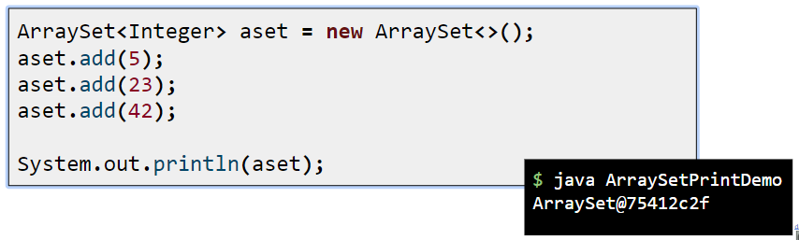

Classes like Arraylist and java arrays have their own overridden versions of the toString() method. This is why, when you were working with and writing tests for Arraylist, errors would always return the list in a nice format like this (1, 2, 3, 4) instead of returning the memory location.

For classes that we've written by ourselves like ArrayDeque, LinkedListDeque, etc, we need to provide our own toString() method if we want to be able to see the objects printed in a readable format.

  @Override

  public String toString() {

    // Warning: This code is slow. Intuition: Adding even a single character to a

    // string creates an entirely new string. It’s because Strings are “immutable”.

    String returnString = "{";

    for (T item : this) {

      returnString += item.toString();// 或者写成returnString += item; Anytime you try to combine a string with a thing

                                      // that is not a string, toString() is called.

      returnString += ", ";

    }

    returnString = returnString.substring(0, returnString.length() - 2);

    returnString += "}";

    return returnString;

  }

To solve the problem caused by using string concatenation, Java has a special class called StringBuilder. It creates a string object that is mutable, so you can continue appending to the same string object instead of creating a new one each time.

  @Override

  public String toString() {

    StringBuilder returnSB = new StringBuilder("{");

    for (int i = 0; i < size - 1; i++) {

      returnSB.append(items[i]);

      returnSB.append(", ");

    }

    returnSB.append(items[size - 1]);

    returnSB.append("}");

    return returnSB.toString();

  }

### sorting your own objects

The toString() method is defined in class Object, so every class in Java inherits the method. And since the toString() method is called on an object when it’s printed (System.out.println(anObject)), you should override it to print something more readable than the default unique identifier code.



### collections with generics



From the API docs (looking up the java.util.Collections class, and scrolling to the sort() method), it looks like the sort() method is declared... strangely. Or at least different from anything we’ve seen so far.

That’s because the sort() method (along with other things in the whole collection framework in Java) makes heavy use of **generics**. Anytime you see something with **angle brackets** in Java source code or documentation, it means generics—a feature added to Java 5.0.

So it looks like we’ll have to learn how to interpret the documentation before we can figure out why we were able to sort String objects in an ArrayList, but not an ArrayList of Song objects.

### Generics means more type-safety

Virtually all of the code you write that deals with generics will be collection-related code. Although generics can be used in other ways, the main point of generics is to let you write type-safe collections. In other words, code that makes the compiler stop you from putting a Dog into a list of Ducks.

Before generics (which means before Java 5.0), the compiler could not care less what you put into a collection, because all collection implementations were declared to hold type Object. You could put anything in any ArrayList; it was like all ArrayLists were declared as ArrayList<Object>.





### Learning generics

Of the dozens of things you could learn about generics, there are really only three that matter to most programmers:







### 黑馬講解

#### 泛型-概述



非泛型ArrayList集合對象測試



運行上述代碼報錯（編譯的時候不出錯，運行的時候出錯，這更加麻煩。）





用泛型集合來修改上述代碼，可以正常編譯和運行



泛型的好處：

① 編譯期間檢查類型

② 減少了數據類型轉換

這是ArrayList相關代碼：



可以把ArrayList<E>中的E理解為形參。這個E具體化，可以是String，Integer，Boolean等。

#### 泛型類

聲明泛型類和普通類相似，只不過在類名稱後面多了尖括號來裝泛型標識（泛型標識=類型的形參）。



K和V結合使用，hash map的鍵值對



示例代碼



package generictest;

/**

 * <T> 泛型標識

 * T 創建對象的時候指定具體的數據類型

 */

public class Generic<T> {

  private T key; // 成員變量

  public Generic(T *key*) { // 構造方法

    this.key = key;

  }

  public T getKey() {

    return key;

  }

  public void setKey(T *key*) {

    this.key = key;

  }

  // Override

  public String toString() {

    return "Generic{" +

        "key=" + key +

        '}';

  }

}

package generictest;

public class MainClass {

  public static void main(String[] *args*) {

    Generic<String> myStrGeneric = new Generic<>("abc");

    String key1 = myStrGeneric.getKey();

    System.out.println("key1:" + key1); // key1:abc

    Generic<Integer> myIntGeneric = new Generic<>(100);

    Integer key2 = myIntGeneric.getKey();

    System.out.println("key2:" + key2);  // key2:100

    // 泛型類在創建對象的時候，如果沒有指定類型，默認類型為Object

    Generic generic = new Generic("ABC")

    // 泛型類不支持基本數據類型。泛型的類型參數只能是類類型。

    // Generic<int> generic4 = new Generic<>(100);

    // 同一泛型類，根據不同的數據類型創建的對象，本質上是同一類型。在這個例子裡，就是class Generic.

    System.out.println(myStrGeneric.getClass() == myIntGeneric.getClass()); // true

  }

}

把上面兩個類的代碼寫在一個類裡面：

public class Generic<T> {

  public static void main(String[] *args*) {

    Generic<String> myStrGeneric = new Generic<>("abc");

    String key1 = myStrGeneric.getKey();

    System.out.println("key1:" + key1);

    Generic<Integer> myIntGeneric = new Generic<>(100);

    Integer key2 = myIntGeneric.getKey();

    System.out.println("key2:" + key2);

  }

  private T key; // 成員變量

  public Generic(T *key*) { // 構造方法

    this.key = key;

  }

  public T getKey() {

    return key;

  }

  public void setKey(T *key*) {

    this.key = key;

  }

  // Override

  public String toString() {

    return "Generic{" +

        "key=" + key +

        '}';

  }

}

#### 泛型類派生子類



如果父類不聲明，默認的是Object類型。

子類繼承父類時，也可以這樣寫

public class ChildFirst<T, E, K> extends Parent<T> {

子類可以多寫幾個，只要保證子類的泛型類含有父類的泛型類即可。

示例代碼見代碼文件。

#### 泛型接口



聲明泛型接口和聲明普通接口類似，只不過在後面多了尖括號裝泛型標識。

如果接口不聲明，默認的是Object類型。



#### 泛型方法

泛型類：在實例化類的時候指明泛型的具體類型。

泛型方法：在調用方法的時候指明泛型的具體類型。





普通的成員方法，如果採用了類的泛型，該方法不能被聲明成靜態方法。

泛型方法可以被聲明為靜態方法。

泛型方法與可變參數



可變參數的泛型定義是在泛型標識後面加上三個點...

泛型方法可以使方法獨立於類而產生變化

#### 類型通配符



示例代碼

public class Box<E> {

  private E first;

  public E getFirst() {

    return first;

  }

  public void setFirst(E *first*) {

    this.first = first;

  }

}

public class Test {

  public static void main(String[] *args*) {

    Box<Number> box1 = new Box<>();

    box1.setFirst(100);

    showBox(box1);

    // 再寫個Integer，這時showBox(Box<Number> box)無法正常使用。

    Box<Integer> box2 = new Box<>();

    box2.setFirst(200);

    showBox(box2);

  }

  // 定義一個方法，參數是一個泛型類。泛型類的類型是Number

  // public static void showBox(Box<Number> box) {

  // Number first = box.getFirst();

  // System.out.println(first);

  // }

  // 如果要同時滿足Box<Number> box1和Box<Integer> box2，上面的showBox(Box<Number>

  // box)無法完成這個任務，所以用下面的方法。？是泛型通配符。

  public static void showBox(Box<?> *box*) {

    Object first = box.getFirst();

    System.out.println(first);

  }

}

#### 類型通配符的上限



#### 類型通配符的下限（2開始到泛型反射有點蒙）



#### 類型擦除





打印結果



無限制類型擦除



有限制類型擦除



擦除方法中類型定義的參數



橋接方法



#### 泛型與數組



開發時盡量別用泛型數組，採用泛型集合代替泛型數組。

#### 泛型反射



### Using generic CLASSES

The two key areas to look at in a generified class are:

1) The class declaration

2) The method declarations that let you add elements



### Using type parameters with ArrayList



### the symbol

Q: Is “E” the only thing you can put there? Because the docs for sort used “T”....

A: You can use anything that’s a legal Java identifier. That means anything that you could use for a method or variable name will work as a type parameter. But the convention is to use a single letter (so that’s what you should use), and a further convention is to use “T” unless you’re specifically writing a collection class, where you’d use “E” to represent the “type of the Element the collection will hold”.

### Using generic METHODS

A generic class means that the class declaration includes a type parameter.

A generic method means that the method declaration uses a type parameter in its signature.

You can use type parameters in a method in several different ways:



When you declare a type parameter for the class, you can simply use that type any place that you’d use a real class or interface type. The type declared in the method argument is essentially replaced with the type you use when you instantiate the class.



If the class itself doesn’t use a type parameter, you can still specify one for a method, by declaring it in a really unusual (but available) space—before the return type. This method says that T can be “any type of Animal”.



Both are legal, but they’re different!

The first one, where <T extends Animal> is part of the method declaration, means that any ArrayList declared of a type that is Animal, or one of Animal’s subtypes (like Dog or Cat), is legal. So you could invoke the top method using an ArrayList<Dog>, ArrayList<Cat>, or ArrayList<Animal>.

But... the one on the bottom, where the method argument is (ArrayList<Animal> list) means that only an ArrayList<Animal> is legal.

下面例子的詳細代碼見CS 61B的Week4- 6.4 reading Object Methods- 4 extra fancier toString() and of()

類ArraySet裡面的部分代碼

  /**

   * 下面有兩個知識點：

   * （1）返回種類ArraySet<EType>前面的<EType>什麼意思？

   * 見java筆記Using generic METHODS.

   * If the class itself does not use a type parameter, you can still specify one

   * for a method,

   * by declaring it in a really unusual (but available) space—before the return

   * type.

   * 这个of()是个static

   * method。是直接用ArraySet这个class来调用，不像實例化ArraySet可以傳遞T的類別，这时候无法传递T（item的类别）。

   * 可以自己在method的signature中定义一下，下面的例子中写的是EType。這裡EType就可以作為這個static

   * method的泛型來傳遞類別。

   * （2）傳遞參數時，EType後面的省略號什麼意思？

   * 例子：private static int sumUp( int... values) {}中，方法參數為「int ...

   * values」，三個點表示values參數可選,並且這個參數不是一個，是一個參數數組。

   * 在下面的例子中，Etype可以是int，也可以是String，或者其它。表示傳遞進來一個int數組或者string數組或者其它数组。

   */

  public static <EType> ArraySet<EType> of(EType... *stuff*) {

    ArraySet<EType> returnArrSet = new ArraySet<>();

    for (EType x : stuff) {

      returnArrSet.add(x);

    }

    return returnArrSet;

  }

在類TestArraySet中測試上述代碼

public class TestArraySet {

  public static void main(String[] *args*) {

    ArraySet<String> aSetOfStrings = ArraySet.of("hi", "I'm", "here");

    System.out.println(aSetOfStrings); //{hi, I’m, here}

  }

}

### Revisiting the sort() method

P546



P547

The sort() method can take only lists of Comparable objects. Song is NOT a subtype of Comparable, so you cannot sort() the list of Songs. At least not yet...













We can pass the ArrayList<Song> to the sort() method only if the Song class implements Comparable, since that’s the way the sort() method was declared. A quick check of the API docs shows the Comparable interface is really simple, with only one method to implement:



The song running the method has to decide how its title compares to the title of the method parameter.

The String class must know about alphabetical order, because the sort() method worked on a list of Strings. We know String has a compareTo() method, so just call it. That way, we can simply let one title String compare itself to another, and we don’t have to write the comparing/alphabetizing algorithm!

### sorting the same thing in more than one way

Look at the Collections class API again. There’s a second sort() method—and it takes a Comparator.



### Using a custom Comparator

An element in a list can compare itself to another of its own type in only one way, using its compareTo() method. But a Comparator is external to the element type you’re comparing—it’s a separate class. So you can make as many of these as you like! Want to compare songs by artist? Make an ArtistComparator. Sort by beats per minute? Make a BPMComparator.



Then all you need to do is call the overloaded sort() method that takes the List and the Comparator that will help the sort() method put things in order.

The sort() method that takes a Comparator will use the Comparator instead of the element’s own compareTo() method, when it puts the elements in order. So, the rules are:



### Updating the Jukebox to use a Comparator



### We need a Set instead of a List

LIST VS SET VS MAP







### The Collection API (part of it)



Notice that the Map interface doesn’t actually extend the Collection interface, but Map is still considered part of the “Collection Framework” (also known as the “Collection API”). So Maps are still collections, even though they don’t include java.util.Collection in their inheritance tree. (Note: this is not the complete collection API; there are other classes and interfaces, but these are the ones we care most about.)



### Using a HashSet instead of ArrayList

P559



### What makes two objects equal?

If two objects foo and bar are equal, foo.equals(bar) must be true, and both foo and bar must return the same value from hashCode().

For a Set to treat two objects as duplicates, you must override the hashCode() and equals() methods inherited from class Object, so that you can make two different objects be viewed as equal.

### reference equality vs. object equality.



Two references that refer to the same object on the heap are equal. Period. If you call the hashCode() method on both references, you’ll get the same result. If you don’t override the hashCode() method, the default behavior (remember, you inherited this from class Object) is that each object will get a unique number (most versions of Java assign a hashcode based on the object’s memory address on the heap, so no two objects will have the same hashcode).

If you want to know if two references are really referring to the same object, use the == operator, which (remember) compares the bits in the variables. If both references point to the same object, the bits will be identical.





If you want to treat two different Song objects as equal (for example if you decided that two Songs are the same if they have matching title variables), you must override both the hashCode() and equals() methods inherited from class Object.

As we said above, if you don’t override hashCode(), the default behavior (from Object) is to give each object a unique hashcode value. So you must override hashCode() to be sure that two equivalent objects return the same hashcode. But you must also override equals() so that if you call it on either object, passing in the other object, always returns true.





### How a HashSet checks for duplicates: hashCode() and equals()

When you put an object into a Hashset, it uses the object’s hashcode value to determine where to put the object in the Set. But it also compares the object’s hashcode to the hashcode of all the other objects in the HashSet, and if there’s no matching hashcode, the HashSet assumes that this new object is not a duplicate. In other words, if the hashcodes are different, the HashSet assumes there’s no way the objects can be equal! So you must override hashCode() to make sure the objects have the same value.



But two objects with the same hashCode() might not be equal (more on this on the next page), so if the HashSet finds a matching hashcode for two objects— one you’re inserting and one already in the set—the HashSet will then call one of the object’s equals() methods to see if these hashcode-matched objects really are equal. And if they’re equal, the HashSet knows that the object you’re attempting to add is a duplicate of something in the Set, so the add doesn’t happen.

You don’t get an exception, but the HashSet’s add() method returns a boolean to tell you (if you care) whether the new object was added. So if the add() method returns false, you know the new object was a duplicate of something already in the set.



### The Song class with overridden hashCode() and equals()



### Java Object Law For HashCode() and equals()

The API docs for class Object state the rules you MUST follow:

* $ If two objects are equal, they MUST have matching hashcodes.
* $ If two objects are equal, calling equals() on either object MUST return true. In other words, if (a.equals(b)) then (b.equals(a)).
* $ If two objects have the same hashcode value, they are NOT required to be equal. But if they’re equal, they MUST have the same hashcode value.
* $ So, if you override equals(), you MUST override hashCode().
* $ The default behavior of hashCode() is to generate a unique integer for each object on the heap. So if you don’t override hashCode() in a class, no two objects of that type can EVER be considered equal.
* $ The default behavior of equals() is to do an == comparison. In other words, to test whether the two references refer to a single object on the heap. So if you don’t override equals() in a class, no two objects can EVER be considered equal since references to two different objects will always contain a different bit pattern. a.equals(b) must also mean that a.hashCode() == b.hashCode() But a.hashCode() == b.hashCode() does NOT have to mean a.equals(b)

### Q: How come hashcodes can be the same even if objects aren’t equal?

A: HashSets use hashcodes to store the elements in a way that makes it much faster to access. If you try to find an object in an ArrayList by giving the ArrayList a copy of the object (as opposed to an index value), the ArrayList has to start searching from the beginning, looking at each element in the list to see if it matches. But a HashSet can find an object much more quickly, because it uses the hashcode as a kind of label on the “bucket” where it stored the element. So if you say, “I want you to find an object in the set that’s exactly like this one...” the HashSet gets the hashcode value from the copy of the Song you give it (say, 742), and then the HashSet says, “Oh, I know exactly where the object with hashcode #742 is stored...”, and it goes right to the #742 bucket.

This isn’t the whole story you get in a computer science class, but it’s enough for you to use HashSets effectively. In reality, developing a good hashcode algorithm is the subject of many a PhD thesis, and more than we want to cover in this book.

The point is that hashcodes can be the same without necessarily guaranteeing that the objects are equal, because the “hashing algorithm” used in the hashCode() method might happen to return the same value for multiple objects. And yes, that means that **multiple objects would all land in the same bucket in the HashSet** (because **each bucket represents a single hashcode value**), but that’s not the end of the world. It might mean that the HashSet is just a little less efficient (or that it’s filled with an extremely large number of elements), but if the HashSet finds more than one object in the same hashcode bucket, the HashSet will simply use the equals() method to see if there’s a perfect match. In other words, hashcode values are sometimes used to narrow down the search, but to find the one exact match, the HashSet still has to take all the objects in that one bucket (the bucket for all objects with the same hashcode) and then call equals() on them to see if the object it’s looking for is in that bucket.

### And if we want the set to stay sorted, we’ve got TreeSet

TreeSet is similar to HashSet in that it prevents duplicates. But it also keeps the list sorted.

It works just like the sort() method in that if you make a TreeSet using the set’s no-arg constructor, the TreeSet uses each object’s compareTo() method for the sort. But you have the option of passing a Comparator to the TreeSet constructor, to have the TreeSet use that instead.

The downside to TreeSet is that if you don’t need sorting, you’re still paying for it with a small performance hit. But you’ll probably find that the hit is almost impossible to notice for most apps.



### TreeSet elements MUST be comparable

P566

To use a TreeSet, one of these things must be true:









### HashMap

Imagine you want a collection that acts like a property list, where you give it a name and it gives you back the value associated with that name. Although keys will often be Strings, they can be any Java object (or, through autoboxing, a primitive).







### Finally, back to generics

If a method argument is an array of Animals, it will also take an array of any Animal subtype.

In other words, if a method is declared as:



Assuming Dog extends Animal, you are free to call both:









### Using polymorphic arguments and generics

Try it with only the Animal ArrayList. We made just a few changes to the go() method:





### But will it work with ArrayList<Dog> ?







### array types checks VS collection type checks



Let’s say you do add a Cat to an array declared as Dog[] (an array that was passed into a method argument declared as Animal[], which is a perfectly legal assignment for arrays).





### Wildcards to the rescue





### Alternate syntax for doing the same thing





Q: If they both do the same thing, why would you use one over the other?

A: It all depends on whether you want to use “T” somewhere else. For example, what if you want the method to have two arguments—both of which are lists of a type that extend Animal? In that case, it’s more efficient to just declare the type parameter once:



## Chapter 17 package, jars and deployment: Release Your Code

### Deploying your application



In this chapter, we’ll look at local deployments, including Executable Jars and the part-local/part-remote technology called Java Web Start. In the next chapter, we’ll look at the more remote deployment options, including RMI and Servlets.





### Separate source code and class files

Bob should have been making sure his compiled class files didn’t land in the same directory as his source code.

**The key is a combination of directory structure organization and the -d compiler option.**

There are dozens of ways you can organize your files, and your company might have a specific way they want you to do it. We recommend an organizational scheme that’s become almost standard, though.

With this scheme, you create **a project directory**, and inside that you create a directory called **source** and a directory called **classes**. You start by saving your source code (.java files) into the source directory. Then the trick is to compile your code in such a way that the output (the .class files) ends up in the classes directory. And there’s a nice compiler flag, -d, that lets you do that.





By using the -d flag, you get to decide which directory the compiled code lands in, rather than accepting the default of class files landing in the same directory as the source code. To compile all the .java files in the source directory, use:





### Put your Java in a JAR

A JAR file is a Java ARchive. It’s based on the pkzip file format, and it lets you bundle all your classes so that instead of presenting your client with 28 class files, you hand over just a single JAR file.

Note: when we say JAR in all caps, we’re referring to the archive file. When we use lowercase, we’re referring to the jar tool you use to create JAR files.

You make the JAR executable. An executable JAR means the end-user doesn’t have to pull the class files out before running the program. The user can run the app while the class files are still in the JAR. The trick is to create a manifest file, that goes in the JAR and holds information about the files in the JAR. To make a JAR executable, the manifest must tell the JVM which class has the main() method!











### Running (executing) the JAR

Java (the JVM) is capable of loading a class from a JAR, and calling the main() method of that class. In fact, the entire application can stay in the JAR. Once the main() method starts running, the JVM doesn’t care where your classes come from, as long as it can find them. And one of the places the JVM looks is within any JAR files in the classpath. If it can see a JAR, the JVM will look in that JAR when it needs to find and load a class.



Depending on how your operating system is configured, you might even be able to simply double-click the JAR file to launch it. This works on most flavors of Windows, and Mac OS X. You can usually make this happen by selecting the JAR and telling the OS to “Open with...” (or whatever the equivalent is on your operating system).

### Put your classes in packages!

Put classes into a package, and JAR the entire package.

 













### Packages prevent class name conflicts

Although packages aren’t just for preventing name collisions, that’s a key feature.

You might write a class named Customer and a class named Account and a class named ShoppingCart. And what do you know, half of all developers working in enterprise e-commerce have probably written classes with those names. In an OO world, that’s just dangerous. If part of the point of OO is to write reusable components, developers need to be able to piece together components from a variety of sources, and build something new out of them. Your components have to be able to ‘play well with others’, including those you didn’t write or even know about.

Remember way back in chapter 6 when we discussed how a package name is like the full name of a class, technically known as the fully-qualified name. Class ArrayList is really java.util.ArrayList, JButton is really javax.swing.JButton, and Socket is really java.net.Socket. Notice that two of those classes, ArrayList and Socket, both have java as their “first name”. In other words, the first part of their fully-qualified names is “java”. Think of a hierarchy when you think of package structures, and organize your classes accordingly.

### package naming

Packages can prevent name conflicts, but only if you choose a package name that’s guaranteed to be unique. The best way to do that is to preface your packages with your reverse domain name. Remember, domain names are guaranteed to be unique.





### Compiling and running with packages



### The -d flag is even cooler than we said





Q: I tried to cd into the directory where my main class was, but now the JVM says it can’t find my class! But it’s right THERE in the current directory!

A: Once your class is in a package, you can’t call it by its ‘short’ name. You MUST specify, at the command-line, the fully-qualified name of the class whose main() method you want to run. But since the fully-qualified name includes the package structure, Java insists that the class be in a matching directory structure. So if at the command-line you say: %java com.foo.Book the JVM will look in its current directory (and the rest of its classpath), for a directory named “com”. It will not look for a class named Book, until it has found a directory named “com” with a directory inside named “foo”. Only then will the JVM accept that it’s found the correct Book class. If it finds a Book class anywhere else, it assumes the class isn’t in the right structure, even if it is!

### Making an executable JAR with packages







### jar commands for listing and extracting





### Java Web Start



End-users launch a Java Web Start app by clicking on a link in a Web page. But once the app downloads, it runs outside the browser, just like any other stand-alone Java application. In fact, a Java Web Start app is just an executable JAR that’s distributed over the Web.

Java Web Start is, among other things, a small Java program that lives on the client machine and works much like a browser plug-in (the way, say, Adobe Acrobat Reader opens when your browser gets a .pdf file). This Java program is called the Java Web Start ‘helper app’, and its key purpose is to manage the downloading, updating, and launching (executing) of your JWS apps.

When JWS downloads your application (an executable JAR), it invokes the main() method for your app. After that, the end-user can launch your application directory from the JWS helper app.

But that’s not the best part. The amazing thing about JWS is its ability to detect when even a small part of application (say, a single class file) has changed on the server, and—without any end-user intervention—download and integrate the updated code.

There’s still an issue, of course, like how does the end-user get Java and Java Web Start? They need both—Java to run the app, and Java Web Start (a small Java application itself) to handle retrieving and launching the app. But even that has been solved. You can set things up so that if your end-users don’t have JWS, they can download it from Sun. And if they do have JWS, but their version of Java is out-of-date (because you’ve specified in your JWS app that you need a specific version of Java), the Java 2 Standard Edition can be downloaded to the end-user machine.

Best of all, it’s simple to use. You can serve up a JWS app much like any other type of Web resource such as a plain old HTML page or a JPEG image. You set up a Web (HTML) page with a link to your JWS application, and you’re in business.

In the end, your JWS application isn’t much more than an executable JAR that end-users can download from the Web.

### How Java Web Start works

Java Web Start includes a ‘**helper app**’ that must be installed on the client (along with Java).

A Java Web Start (JWS) app has two pieces: an executable JAR and a .jnlp file.











### The .jnlp file

To make a Java Web Start app, you need to create a .jnlp (Java Network Launch Protocol) file that describes your application. This is the file the JWS app reads and uses to find your JAR and launch the app (by calling the JAR’s main() method). A .jnlp file is a simple XML document that has several different things you can put in, but as a minimum, it should look like this:









### Steps for making and deploying a Java Web Start app







### Q: How is Java Web Start different from an applet?

A: Applets can’t live outside of a Web browser. An applet is downloaded from the Web as part of a Web page rather than simply from a Web page. In other words, to the browser, the applet is just like a JPEG or any other resource.

The browser uses either a Java plug-in or the browser’s own built-in Java (far less common today) to run the applet. Applets must always be launched from the browser.

Applets don’t have the same level of functionality for things such as automatic updating.

With JWS applications, once they’re downloaded from the Web, the user doesn’t even have to be using a browser to relaunch the application locally. Instead, the user can start up the JWS helper app, and use it to launch the already-downloaded application again.

### Q: What are the security restrictions of JWS?

A: JWS apps have several limitations including being restricted from reading and writing to the user’s hard drive.

But... JWS has its own API with a special open and save dialog box so that, with the user’s permission, your app can save and read its own files in a special, restricted area of the user’s drive.

## Chapter 18 remote deployment with RMI: Distributed Computing

Remote Method Invocation (RMI) technology



### Method calls are always between two objects on the same heap.



In the code above, we know that the Foo instance referenced by f and the Bar object referenced by b are both on the same heap, run by the same JVM.

The JVM is responsible for stuffing bits into the reference variable that represent how to get to an object on the heap. The JVM always knows where each object is, and how to get to it.

But the JVM can know about references on only its own heap! You can’t, for example, have a JVM running on one machine knowing about the heap space of a JVM running on a different machine. In fact, a JVM running on one machine can’t know anything about a different JVM running on the same machine. It makes no difference if the JVMs are on the same or different physical machines; it matters only that the two JVMs are, well, two different invocations of the JVM.

### A design for remote method calls

Create four things: server, client, server helper, client helper









### client and server helpers



The ‘helpers’ are the objects that actually do the communicating. They make it possible for the client to act as though it’s calling a method on a local object.

The client calls a method on the client helper. The client helper is a proxy for the service object, pretending to be the thing with the method the client wants to call, because the client helper has the same method that the service is advertising.

The client helper doesn’t have any of the actual method logic the client is expecting. Instead, the client helper contacts the server, transfers information about the method call (e.g., name of the method, arguments, etc.), and waits for a return from the server.

On the server side, the service helper receives the request from the client helper (through a Socket connection), unpacks the information about the call, and then invokes the real method on the real service object.

The service helper gets the return value from the service, packs it up, and ships it back (over a Socket’s output stream) to the client helper. The client helper unpacks the information and returns the value to the client object.



### How the method call happens







### Java RMI gives you the client and service helper objects!

In Java, RMI builds the client and service helper objects for you. RMI knows how to give the client helper object the same methods you want to call on the remote service.

Plus, RMI provides all the runtime infrastructure to make it work, including a lookup service so that the client can find and get the client helper (the proxy for the Real Service).

With RMI, you don’t write any of the networking or I/O code yourself.

There is one difference between RMI calls and local (normal) method calls. Networking and I/O methods are risky. They throw exceptions all over the place. So, the client does have to acknowledge the risk.

How the information about that call gets transferred from one JVM to another depends on the protocol used by the helper objects.

With RMI, you have a choice of protocols: JRMP or IIOP. JRMP is RMI’s ‘native’ protocol, the one made just for Java-to-Java remote calls. IIOP, on the other hand, is the protocol for CORBA (Common Object Request Broker Architecture), and lets you make remote calls on things which aren’t necessarily Java objects. CORBA is usually much more painful than RMI, because if you don’t have Java on both ends, there’s an awful lot of translation and conversion that has to happen. But thankfully, all we care about is Java-to-Java, so we’re sticking with plain old, remarkably easy RMI.

### In RMI, the client helper is a ‘stub’ and the server helper is a ‘skeleton’.

When a client calls a method on a remote object, the client is really calling a method on a proxy of the remote object. The proxy is called a ‘stub’.

A stub is a client helper object that takes care of the low-level networking details (sockets, streams, serialization, etc.) by packaging and sending method calls to the server.



### Making the Remote Service











### Step one: Make a Remote Interface













### Step two: Make a Remote Implementation











### Step three: generate stubs and skeletons





The rmic tool, that comes with the Java software development kit, takes a service implementation and creates two new classes, the stub and the skeleton.

It uses a naming convention that is the name of your remote implementation, with either _Stub or _Skel added to the end.

There are other options with rmic, including not generating skeletons, seeing what the source code for these classes looked like, and even using IIOP as the protocol.

The way we’re doing it here is the way you’ll usually do it. The classes will land in the current directory (i.e. whatever you did a cd to). Remember, rmic must be able to see your implementation class, so you’ll probably run rmic from the directory where your remote implementation is. (We’re deliberately not using packages here, to make it simpler. In the Real World, you’ll need to account for package directory structures and fullyqualified names).

### Step four: run rmiregistry



### Step five: start the service



### Complete code for the server side













### How does the client get the stub object?

The client has to get the stub object, since that’s the thing the client will call methods on. And that’s where the RMI registry comes in. The client does a ‘lookup’, like going to the white pages of a phone book, and essentially says, “Here’s a name, and I’d like the stub that goes with that name.”





### How does the client get the stub class?

In a simple system, you can simply hand-deliver the stub class to the client.

There’s a much cooler way, though, although it’s beyond the scope of this book. But just in case you’re interested, the cooler way is called “dynamic class downloading”. With dynamic class downloading, a stub object (or really any Serialized object) is ‘stamped’ with a URL that tells the RMI system on the client where to find the class file for that object. Then, in the process of deserializing an object, if RMI can’t find the class locally, it uses that URL to do an HTTP Get to retrieve the class file. So, you’d need a simple Web server to serve up class files, and you’d also need to change some security parameters on the client. There are a few other tricky issues with dynamic class downloading, but that’s the overview.



### Be sure each machine has the class files it needs.

The top three things programmers do wrong with RMI are:

1) Forget to start rmiregistry before starting remote service (when you register the service using Naming.rebind(), the rmiregistry must be running!) 2) Forget to make arguments and return types serializable (you won’t know until runtime; this is not something the compiler will detect.) 3) Forget to give the stub class to the client.



### What about Servlets?



Servlets are Java classes that run entirely on (and/or within) an HTTP (web) server.

Servlets are Java programs that run on (and with) an HTTP web server. When a client uses a web browser to interact with a web page, a request is sent back to the web server. If the request needs the help of a Java servlet, the web server runs (or calls, if the servlet is already running) the servlet code.

Servlet code is simply code that runs on the server, to do work as a result of whatever the client requests (for example, save information to a text file or database on the server). If you’re familiar with CGI scripts written in Perl, you know exactly what we’re talking about. Web developers use CGI scripts or servlets to do everything from sending user-submitted info to a database, to running a web-site’s discussion board.

And even servlets can use RMI!

By far, the most common use of J2EE technology is to mix servlets and EJBs together, where servlets are the client of the EJB. And in that case, the servlet is using RMI to talk to the EJBs. (Although the way you use RMI with EJB is a little different from the process we just looked at.)









### Steps for making and running a servlet

To run a servlet, you must have a web server capable of running servlets, such as the Tomcat server from apache.org.











### A very simple Servlet





A typical servlet extends HttpServlet and overrides one or more servlet methods, such as doGet() or doPost().



### Q: What’s a JSP, and how does it relate to servlets?

A: JSP stands for Java Server Pages. In the end, the web server turns a JSP into a servlet, but the difference between a servlet and a JSP is what YOU (the developer) actually create. With a servlet, you write a Java class that contains HTML in the output statements (if you’re sending back an HTML page to the client). But with a JSP, it’s the opposite—you write an HTML page that contains Java code!

This gives you the ability to have dynamic web pages where you write the page as a normal HTML page, except you embed Java code (and other tags that “trigger” Java code at runtime) that gets processed at runtime. In other words, part of the page is customized at runtime when the Java code runs.

The main benefit of JSP over regular servlets is that it’s just a lot easier to write the HTML part of a servlet as a JSP page than to write HTML in the torturous print out statements in the servlet’s response.

But for many applications, it isn’t necessary to use JSPs because the servlet doesn’t need to send a dynamic response, or the HTML is simple enough not to be such a big pain. And, there are still many web servers out there that support servlets but do not support JSPs, so you’re stuck.

Another benefit of JSPs is that you can separate the work by having the Java developers write the servlets and the web page developers write the JSPs. That’s the promised benefit, anyway. In reality, there’s still a Java learning curve (and a tag learning curve) for anyone writing a JSP, so to think that an HTML web page designer can bang out JSPs is not realistic. Well, not without tools. But that’s the good news—authoring tools are starting to appear, that help web page designers create JSPs without writing the code from scratch.

### Q: Is this all you’re gonna say about servlets? After such a huge thing on RMI?

A: Yes. RMI is part of the Java language, and all the classes for RMI are in the standard libraries. Servlets and JSPs are not part of the Java language; they’re considered standard extensions. You can run RMI on any modern JVM, but Servlets and JSPs require a properly configured web server with a servlet “container”. This is our way of saying, “it’s beyond the scope of this book.” But you can read much more in the lovely Head First Servlets & JSP.

### Enterprise JavaBeans: RMI on steroids (with a bunch of managers)

RMI is great for writing and running remote services. But you wouldn’t run something like an Amazon or eBay on RMI alone. For a large, deadly serious, enterprise application, you need something more. You need something that can handle transactions, heavy concurrency issues (like a gazillion people are hitting your server at once to buy those organic dog kibbles), security (not just anyone should hit your payroll database), and data management. For that, you need an enterprise application server.

In Java, that means a Java 2 Enterprise Edition (J2EE) server. A J2EE server includes both a web server and an Enterprise JavaBeans(EJB) server, so that you can deploy an application that includes both servlets and EJBs.

Like servlets, EJB is way beyond the scope of this book, and there’s no way to show “just a little” EJB example with code, but we will take a quick look at how it works. (For a much more detailed treatment of EJB, we can recommend the lively Head First EJB certification study guide.)

An EJB server adds a bunch of services that you don’t get with straight RMI. Things like transactions, security, concurrency, database management, and networking. An EJB server steps into the middle of an RMI call and layers in all of the services.



### Jini is RMI with wings

Jini uses RMI (although other protocols can be involved), but gives you a few key features including:

**Adaptive discovery**

**Self-healing networks**

With Jini, the client has to know only one thing: the interface implemented by the service! That’s it.

The trick revolves around Jini lookup services. Jini lookup services are far more powerful and flexible than the RMI registry. For one thing, Jini lookup services announce themselves to the network, automatically. When a lookup service comes online, it sends a message (using IP multicast) out to the network saying, “I’m here, if anyone’s interested.”

But that’s not all. Let’s say you (a client) come online after the lookup service has already announced itself, you can send a message to the entire network saying, “Are there any lookup services out there?”

Except that you’re not really interested in the lookup service itself—you’re interested in the services that are registered with the lookup service. Things like RMI remote services, other serializable Java objects, and even devices such as printers, cameras, and coffeemakers.

And here’s where it gets even more fun: when a service comes online, it will dynamically discover (and register itself with) any Jini lookup services on the network. When the service registers with the lookup service, the service sends a serialized object to be placed in the lookup service. That serialized object can be a stub to an RMI remote service, a driver for a networked device, or even the whole service itself that (once you get it from the lookup service) runs locally on your machine. And instead of registering by name, the service registers by the interface it implements.

Once you (the client) have a reference to a lookup service, you can say to that lookup service, “Hey, do you have anything that implements ScientificCalculator?” At that point, the lookup service will check its list of registered interfaces, and assuming it finds a match, says back to you, “Yes I do have something that implements that interface. Here’s the serialized object the ScientificCalculator service registered with me.”

### Adaptive discovery in action









### Self-healing network in action









### Final Project: the Universal Service browser

We’re going to make something that isn’t Jini-enabled, but quite easily could be. It will give you the flavor and feeling of Jini, but using straight RMI. In fact the main difference between our application and a Jini application is how the service is discovered. Instead of the Jini lookup service, which automatically announces itself and lives anywhere on the network, we’re using the RMI registry which must be on the same machine as the remote service, and which does not announce itself automatically.

And instead of our service registering itself automatically with the lookup service, we have to register it in the RMI registry (using Naming.rebind()).

But once the client has found the service in the RMI registry, the rest of the application is almost identical to the way we’d do it in Jini. (The main thing missing is the lease that would let us have a self-healing network if any of the services go down.) The universal service browser is like a specialized web browser, except instead of HTML pages, the service browser downloads and displays interactive Java GUIs that we’re calling universal services.



### How it works











### The classes and interfaces













Java總結

## Java中 int和Integer的區別

### （1）區別

Integer是int的包裝類，int則是java的一種基本數據類型

Integer變量必須實例化後才能使用，而int變量不需要

Integer實際是對象的引用，當new一個Integer時，實際上是生成一個指針指向此對象；而int則是直接存儲數據值

Integer的默認值是null，int的默認值是0

類似的還有：float Float;double Double;boolean Boolean等

### （2）比較

**2.1、由於Integer變量實際上是對一個Integer對象的引用，所以兩個通過new生成的Integer變量永遠是不相等的（因為new生成的是兩個對象，其內存地址不同）。**



**2.2、Integer變量和int變量比較時，只要兩個變量的值是相等的，則結果為true（因為包裝類Integer和基本數據類型int比較時，java會自動拆包裝為int，然後進行比較，實際上就變為兩個int變量的比較）**



**2.3、非new生成的Integer變量和new Integer()生成的變量比較時，結果為false。（因為非new生成的Integer變量指向的是java常量池中的對象，而new Integer()生成的變量指向堆中新建的對象，兩者在內存中的地址不同）**



**2.4、對於兩個非new生成的Integer對象，進行比較時，如果兩個變量的值在區間-128到127之間，則比較結果為true，如果兩個變量的值不在此區間，則比較結果為false**



原因：

java在編譯Integer i = 100 ;時，會翻譯成為Integer i = Integer.valueOf(100)；，而java API中對Integer類型的valueOf的定義如下：



java對於-128到127之間的數，會進行緩存，Integer i = 127時，會將127進行緩存，下次再寫Integer j = 127時，就會直接從緩存中取，就不會new了。

**2.5、當需要往ArrayList，HashMap中放東西時**

需要往ArrayList，HashMap中放東西時，無法放入int，double這種內建類型，因為容器都是裝 object的，只能放入外覆類Integer、Double等。

舉例說明

　　ArrayList al=new ArrayList();

　　int n=40;

　　Integer nI=new Integer(n);

　　al.add(n);//不可以

　　al.add(nI);//可以

**2.6、定義泛型**

泛型定義時也不支持int:

如：

List<Integer> list = new ArrayList<Integer>();可以

而List<int> list = new ArrayList<int>();則不行。

**2.7、總而言之**

如果用來進行一些加減乘除的運算or作為參數進行傳遞，可聲明int基本數據類型。

如果要像對象一樣來進行處理，就用Integer聲明一個對象。

### （3）延伸

**3.1、理解自動裝箱、拆箱**

自動裝箱與拆箱實際上算是一種「語法糖」。所謂語法糖，可簡單理解為Java平臺為我們自動進行了一些轉換，保證不同的寫法在運行時等價。因此它們是發生在編譯階段的，也就是說生成的字節碼是一致的。

對於整數，javac替我們自動把裝箱轉換為Integer.valueOf()，把拆箱替換為Integer.intValue()。可以通過將代碼編譯後，再反編譯加以證實。

原則上，建議避免無意中的裝箱、拆箱行為，尤其是在性能敏感的場合，創建10萬個Java對象和10萬個整數的開銷可不是一個數量級的。當然請註意，只有確定你現在所處的場合是性能敏感的，才需要考慮上述問題。畢竟大多數的代碼還是以開發效率為優先的。

順帶說一下，在32位環境下，Integer對象占用內存16字節；在64位環境下則更大。

**3.2、值緩存**

就像上一講談到的String，Java也為Integer提供了值緩存。

Integer i1 = 1;

Integer i2 = Integer.valueOf(2);

Integer i3 = new Integer(3);

上述代碼中第一行與第二行的寫法取值使用了值緩存，而第三行的寫法則沒有利用值緩存。結合剛剛講到的自動裝箱、拆箱的知識，第一行代碼用到的自動裝箱，等價於調用了Integer.valueOf()。

不僅僅是Integer，Java也為其它包裝類提供了值緩存機製，包括Boolean、Byte、Short和Character等。但與String不同的是，默認都只會將絕對值較小的值放入緩存。以Integer為例，默認情況下只會緩存-128到127之間的值。當然如果你願意也可以通過以下JVM參數進行設置：

-XX:AutoBoxCacheMax=N

## Java中length、length()、size()的區別

綜述：

* length——數組的屬性；
* length()——String的方法；
* size()——集合的方法；

### （1）length

length不是方法，是屬性，數組的屬性；

public static void main(String[] args) {

int[] intArray = {1,2,3};

System.out.println("這個數組的長度為：" + intArray.length);

}

### （2）length()

length()是字符串String的一個方法；

public static void main(String[] args) {

String str = "HelloWorld";

System.out.println("這個字符串的長度為：" + str.length());

}

進入length()方法看一下實現

private final char value[];

public int length() {

return value.length;

}

註釋中的解釋是

@return the length of the sequence of characters represented by this object.

即由該對象所代表的字符序列的長度，所以歸根結底最後要找的還是length這個底層的屬性

### （3）size()

size()方法，是List集合的一個方法；

public static void main(String[] args) {

List<String> list = new ArrayList<String>();

list.add("a");

list.add("b");

list.add("c");

System.out.println("这个list的长度为：" + list.size());

}

在List的方法中，是沒有length()方法的；

也看一段ArrayList的源碼

private final E[] a;

ArrayList(E[] array) {

if (array==null)

throw new NullPointerException();

a = array;

}

public int size() {

return a.length;

}

由這段就可以看出list的底層實現其實就是數組，size()方法最後要找的其實還是數組的length屬性；

另外，除了List，Set和Map也有size()方法，所以準確說size()方法是針對集合而言。

## Array 和 ArrayList

What an arraylist is is a wrapper around an array that makes the arraylist so much easier to work with.

An arraylist is part of Java’s collections, so there are a lot of useful methods. You can see what it contains, see if it is empty, sort the list.

Array（[]）：最高效；但是其容量固定且無法動態改變； ArrayList： 容量可動態增長；但犧牲效率；

推薦使用ArrayList

### （1）聲明方式和長度

Array: holding a collection of the same type of objects, like numbers and dogs

Arrays in Java have a fixed size.

    // 兩種聲明array的方法

    // 注意：array的長度設定了就不可更改。

    String[] friendsArray = new String[4]; // 只声明了array的长度。等会再添加内容。

    String[] friendsArray2 = {"John", "Mia", "Bradley", "Lizzy"};

The size of an ArrayList does not have to be specified when you initiate it.

ArrayList does not have a fixed size.

    // 記得先引入import java.util.ArrayList;

    // 聲明ArrayList的時候不需要確定長度。長度可隨時更改。

    // 兩種聲明ArrayList的方法

    ArrayList<String> friendsArrayList = new ArrayList<>();

    ArrayList<String> friendsArrayList2 = new ArrayList<>(Arrays.asList("John", "Mia", "Bradley", "Lizzy"));

### （2）the data they hold

An array can hold anything (a primitive data type like an int, a long, a boolean; an object like String, Dog).

An arrayList can only hold an object.

如果要把primitive放進ArrayList，把primitive包起來變成object。

### （3）取值

    String[] friendsArray = { "John", "Mia", "Bradley", "Lizzy" };

    System.out.println(friendsArray[1]); // Mia

    System.out.println(friendsArray.length); // 4

    ArrayList<String> friendsArrayList = new ArrayList<>(Arrays.asList("John", "Mia", "Bradley", "Lizzy"));

    System.out.println(friendsArrayList.get(1)); // Mia

    System.out.println(friendsArrayList.size()); // 4

### （4）加值

Array無法加

    ArrayList<String> friendsArrayList = new ArrayList<>(Arrays.asList("John", "Mia", "Bradley", "Lizzy"));

    System.out.println(friendsArrayList.size()); // 4

    friendsArrayList.add("Jane");

    System.out.println(friendsArrayList.size()); // 5

### （5）改值

    String[] friendsArray = { "John", "Mia", "Bradley", "Lizzy" };

    friendsArray[0] = "Carl";

    System.out.println(friendsArray[0]); // Carl

    ArrayList<String> friendsArrayList = new ArrayList<>(Arrays.asList("John", "Mia", "Bradley", "Lizzy"));

    friendsArrayList.set(0, "Aria");

    System.out.println(friendsArrayList.get(0)); // Aria

### （6）刪值

Array無法刪

    ArrayList<String> friendsArrayList = new ArrayList<>(Arrays.asList("John", "Mia", "Bradley", "Lizzy"));

    // 两种方法都行

    // friendsArrayList.remove(0);

    friendsArrayList.remove("John");

    System.out.println(friendsArrayList.get(0)); // Mia

### （7）打印

    String[] friendsArray = { "John", "Mia", "Bradley", "Lizzy" };

    System.out.println(friendsArray); // [Ljava.lang.String;@1b68b9a4 This is the memory address of the array.

    ArrayList<String> friendsArrayList = new ArrayList<>(Arrays.asList("John", "Mia", "Bradley", "Lizzy"));

    System.out.println(friendsArrayList); // [John, Mia, Bradley, Lizzy]

### （8）Array和ArrayList的相互轉換

public class Test {

public static void main(String[] args) {

List<String> list=new ArrayList<String>();

list.add("王利虎");

list.add("张三");

list.add("李四");

int size=list.size();

String[] array = (String[])list.toArray(new String[size]);

for(int i=0;i<array.length;i++){

System.out.println(array[i]);

}

}

}

package test.test1;

import java.util.Arrays;

import java.util.List;

public class Test {

public static void main(String[] args) {

String[] array=new String[3];

array[0]="王利虎";

array[1]="张三";

array[2]="李四";

List<String> list=Arrays.asList(array);

for(int i=0;i<list.size();i++){

System.out.println(list.get(i));

}

}

}

## List 和 ArrayList

### （1）實例化

List是一個接口，ArrayList是List接口的一個實現類。ArrayList類繼承並實現了List接口。

因此，List接口不能被構造，也就是不能創建實例對象，但是可以為List接口創建一個指向自己的對象引用，而ArrayList實現類的實例對象就在這充當了這個指向List接口的對象引用。

接口和抽象不能被實例化，但是它們可以創建一個指向自己的對象引用，它們的實現類或子類就在充當這樣的角色。

List list;//正確，list = null;

List list = new List();//是錯誤的用法

例子。定義一個動物的抽象類Animal，再定義一個繼承自Animal基類的Dog類，看下面的代碼就會理解抽象類和接口不能被實例化：

public class ListAndArrayList {

  public static void main(String[] *args*) {

Animal a1 = new Animal();// 編譯出錯

    Animal a2 = new Dog();

  }

}

abstract class Animal {

  // 动物名字

  String name;

  // 动物叫声

  public void shout() {

    System.out.println("叫声...");

  }

}

class Dog extends Animal {

  // 狗类独有的方法

  public void guard() {

    System.out.println("狗有看门的独特本领！");

  }

}

運行結果：



### （2）調用方法

List list = new ArrayList(); // 這句創建了一個ArrayList實現類的對象後，把它上溯到了List接口。此時list就是一個List對象了。那些ArrayList類具有的、List接口沒有的屬性和方法，list無法使用。

而ArrayList list=newArrayList(); 創建的對象則保留了ArrayList的所有屬性和方法。

繼續上面animal的例子，對象a2是抽象類Animal的對象引用，a2只能調用自己的方法，即shout()方法；a2不能調用繼承Animal的子類Dog的獨有的方法，即guard()方法。

public class ListAndArrayList {

  public static void main(String[] *args*) {

    // Animal a1 = new Animal();// 編譯出錯

    Animal a2 = new Dog();

    a2.shout(); // 可以調用

    // a2.guard(); // 無法調用

  }

}

abstract class Animal {

  // 动物名字

  String name;

  // 动物叫声

  public void shout() {

    System.out.println("shout...");

  }

}

class Dog extends Animal {

  // 狗类独有的方法

  public void guard() {

    System.out.println("guard");

  }

}

反之，如果Dog d1 = new Dog();那麽d1可以調用抽象類Animal和子類Dog的所有屬性和方法。

回到List和ArrayList上：

List a=new ArrayList();

則a擁有List的所有屬性和方法，不會擁有其實現類ArrayList的獨有的屬性和方法。

ArrayList a2 = new ArrayList();

則a2擁有List和ArrayList所有的屬性和方法。

### （3）List list = new ArrayList()用途

為什麽要用 List list = new ArrayList() ,而不用 ArrayList alist = new ArrayList()呢？

List接口有多個實現類。現在用ArrayList，也許以後想用LinkedList、Vector等實現類，這時只要改這一行即可： List list = new LinkedList(); 其它代碼無需改動。

而如果一開始用的是ArrayList alist = new ArrayList()，想改為LinkedList，要改動的地方非常多，特別是在使用了ArrayList實現類特有的方法和屬性的情況下。

如果開發的時候覺得ArrayList,HashMap的性能不能滿足需要，可實現List,Map(或者Collection)來定製自定義類。

## Java iterator

### （1）如何遍歷List？

① 普通for循環

List的實現類都是有序的，可以通過索引號來獲得元素。

② 增強for循環

既能遍歷List集合，也能遍歷Set集合

③ Iterator迭代器

既能遍歷List集合，也能遍歷Set集合

### （2）如何獲得Iterator迭代器？

通過Collection接口提供的“Iterator<E> iterator();”方法獲得迭代器。

### （3）Iterator方法

boolean hasNext();

判斷是否還有下一個元素，有則返回true，無則返回false。

E next();

獲得下一個元素。

### （4）while循環執行迭代器

import java.util.*;

public class RemoveDuplicates {

  public static void main(String[] *args*) {

    Integer[] nums = { 1200, 12, 6, 6, 6, 5, 5, 8, 8, 7, 11 };

    // HashSet和TreeSet都行

    HashSet<Integer> hSet = new HashSet<>(Arrays.asList(nums));

    // TreeSet<Integer> hSet = new TreeSet<Integer>(Arrays.asList(nums));

    // 獲取迭代器

    Iterator<Integer> i = hSet.iterator();

    // 用迭代器循環數字

    while (i.hasNext()) {

      System.out.println(i.next());

    }

  }

}

* 得到迭代器時，會有個標記指向hSet的i=-1的位置
* 然後執行while的i.hasNext()（i=0的位置）
* System.out.println(i.next())打印出來的是i=0的元素
* 此時迭代器的標記指向hSet的i=0的位置
* 繼續執行while循環，直到i.hasNext()為空

### （5）for循環執行迭代器

    for (Iterator<Integer> i = hSet.iterator(); i.hasNext();) {

      System.out.println(i.next());

    }

一般用while循環，很少用for循環。因為前者代碼好看些。

### （6）迭代器遍歷過程中刪除元素

應該用Iterator迭代器提供的remove()方法。

而不能用Collection接口提供的remove(E element)方法。

import java.util.*;

public class RemoveDuplicates {

  public static void main(String[] *args*) {

    Integer[] nums = { 1200, 12, 6, 6, 6, 5, 5, 8, 8, 7, 11 };

    // HashSet和TreeSet都行

    HashSet<Integer> hSet = new HashSet<>(Arrays.asList(nums));

    // TreeSet<Integer> hSet = new TreeSet<Integer>(Arrays.asList(nums));

    // 獲取迭代器

    Iterator<Integer> i = hSet.iterator();

    // 用迭代器循環數字

    while (i.hasNext()) {

      if (i.next() == 5) {

        i.remove();

      }

    }

    System.out.println(hSet); // [1200, 6, 7, 8, 11, 12]

  }

}

### （7）增強for循環和迭代器

增強for循環的底層，用的是Iterator迭代器來實現的。

* 增強for循環既可遍歷集合，又可遍歷數組。Iterator只能遍歷集合。
* 增強for循環遍歷集合時不能刪除元素。Iterator遍歷集合時，可以使用Iterator的remove()方法刪除元素。

## 數組除去重複數據

### （1）Array轉List（遍歷去重）

先寫個array nums

遍歷array nums，一邊去重，一邊把元素加入List中

import java.util.*;

public class RemoveDuplicates {

  public static void main(String[] *args*) {

    int[] nums = { 5, 6, 6, 6, 8, 8, 7, 4 };

    List<Integer> numList = new ArrayList<>();

    for (int i = 0; i < nums.length; i++) {

      if (!numList.contains(nums[i])) {

        numList.add(nums[i]);

      }

    }

    System.out.println(numList); // [5, 6, 8, 7, 4]

  }

}

### （2）Array(int)轉List（遍歷）轉Set

import java.util.*;

public class RemoveDuplicates {

  public static void main(String[] *args*) {

    // array

    int[] nums = { 1200, 12, 6, 6, 6, 5, 5, 8, 8, 7, 11 };

    // 用遍歷的方法把array轉List

    List<Integer> numList = new ArrayList<Integer>();

    for (int i : nums) {

      numList.add(i);

    }

    // 把List轉Set

    // HashSet

    Set<Integer> numHSet = new HashSet<Integer>();

    numHSet.addAll(numList);

    // TreeSet

    Set<Integer> numTSet = new TreeSet<Integer>();

    numTSet.addAll(numList);

    System.out.println(numHSet); // [1200, 5, 6, 7, 8, 11, 12]

    System.out.println(numTSet); // [5, 6, 7, 8, 11, 12, 1200]

  }

}

### （3）Array(Integer)轉List（Arrays.asList()）轉Set

先寫個array nums

用Arrays.asList()再把array nums 轉換成List

再把List轉換成HashSet和TreeSet

import java.util.*;

public class RemoveDuplicates {

  public static void main(String[] *args*) {

    Integer[] nums = { 1200, 12, 6, 6, 6, 5, 5, 8, 8, 7, 11 }; // 這裡必須用Integer[]，否則無法用下面的Arrays.asList()方法

    // HashSet和TreeSet都行

    HashSet<Integer> hSet = new HashSet<>(Arrays.asList(nums));

    TreeSet<Integer> tSet = new TreeSet<Integer>(Arrays.asList(nums));

    System.out.println(hSet); // [1200, 5, 6, 7, 8, 11, 12]

    System.out.println(tSet); // [5, 6, 7, 8, 11, 12, 1200]

  }

}

其中Arrays.asList()是將一個數組轉化為一個List對象，這個方法會返回一個ArrayList類型的對象。這個ArrayList類並非java.util.ArrayList類，而是Arrays類的靜態內部類。

Arrays.asList()適用於對象型數據的數組（String、Integer...）。不建議使用於基本數據類型的數組（byte,short,int,long,float,double,boolean）。

## HashSet和TreeSet的區別

HashSet和TreeSet中的值都不能重復。

### （1）HashSet

HashSet不保證排序（但有時候會自動排序）。HashSet中的數據是無序的。

HashSet集合元素可以是null,但只能放入一個null。

HashSet 是哈希表實現的。

向HashSet集合中存入一個元素時，HashSet會調用該對象的hashCode()方法來得到該對象的hashCode值，然後根據 hashCode值來決定該對象在HashSet中存儲位置。

HashSet集合判斷兩個元素相等的標準是兩個對象通過equals方法比較相等，並且兩個對象的hashCode()方法返回值相等。

HashSet要求放入的對象必須實現HashCode()方法。放入的對象，是以hashcode碼作為標識的。例如，具有相同內容的 String對象，hashcode是一樣，放入的內容不能重復。但是同一個類的對象可以放入不同的實例。

### （2）TreeSet

TreeSet保證排序。Treeset中的數據是自動排好序的。

TreeSet不允許放入null值。

TreeSet 是二差樹實現的。

TreeSet是SortedSet接口的唯一實現類。

TreeSet支持兩種排序方式，自然排序和定製排序，其中自然排序為默認的排序方式。

#### ① 自然排序

自然排序使用要排序元素的CompareTo（Object obj）方法來比較元素之間大小關系，然後將元素按照升序排列。

Java提供了一個Comparable接口，該接口裏定義了一個compareTo(Object obj)方法，該方法返回一個整數值，實現了該接口的對象就可以比較大小。

obj1.compareTo(obj2)方法如果返回0，則說明被比較的兩個對象相等，如果返回一個正數，則表明obj1大於obj2，如果是負數，則表明obj1小於obj2。

如果我們將兩個對象的equals方法總是返回true，則這兩個對象的compareTo方法返回應該返回0。

TreeSet判斷兩個對象不相等的方式是兩個對象通過equals方法返回false，或者通過CompareTo方法比較沒有返回0。

#### ② 定製排序

如果要定製排序，使用Comparator接口，實現 int compare(T o1,T o2)方法。

## equals()和==的區別

### （1）總結Java的基本數據類型和引用類型

八大基本數據類型：byte，short，int，long，double，folat，boolean，char。

其中占一個字節的是byte。short和char占兩個字節。int，float占四個字節。double和long占8個字節。boolean只有true和false。這八種數據變量中直接存儲值

八大基本數據類型對應著各自的封裝類型，提供了更多的方法，且不進行初始化時值默認為空（基本數據類型必須初始化）。

String類型屬於引用類型，變量中存儲的是地址，對應的地址存儲數據。

如果是基本類型比較，那麽只能用==來比較，不能用equals()。

對於基本類型的包裝類型，比如Boolean、Character、Byte、Shot、Integer、Long、Float、Double等的引用變量，==是比較地址的，而equals()是比較內容的。

如果是其他類或者自己寫的類，如有需要，得重寫equals()，因為the default implementation of equals just uses ==.

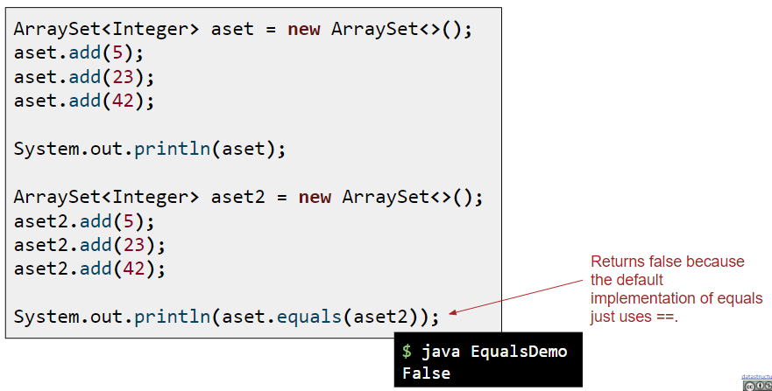

### （2）equals和==

public class EqualsTest {

    public static void main(String[] *args*) {

        // TODO Auto-generated method stub

        Integer aaa=new Integer(5); // 這是2018年的例子，到2022年2月1日這種寫法deprecated。

        Integer bbb=new Integer(5); // 這是2018年的例子，到2022年2月1日這種寫法deprecated。

        int a=10;

        int b=10;

        String str1=new String("justice");

        String str2=new String("justice");

        String str3;

        str3=str1;

        System.out.println(aaa==bbb); // false

        System.out.println(aaa.equals(bbb)); // true

        System.out.println(a==b); // true

        System.out.println(str1==str2); // false

        System.out.println(str1.equals(str2)); // true

        System.out.println(str1==str3); // true

        System.out.println(str1.equals(str3)); // true

    }

}

aaa和bbb都是Integer封裝類型，是不同的對象，變量存儲地址， 所以==結果為false，equals為true。

a和b都是基本數據類型，變量存儲值，所以==為true，基本數據類型無equals方法（沒有意義）。

str1和str2都是String類型，屬於引用類型，變量存儲地址，所以==為false。

String 類中重寫了 equals() 方法用於比較兩個字符串的內容是否相等。所以equals為true。

創建str3的時候，str3指向了str1，所以str1和str3的指向同一個地址，存儲的數據自然相同，所以均為true。

### == 和equal() (CS 61B)

== compares the bits. == checks if two memory boxes hold the same thing.

For primitives, == means checking if the values are equal.

For objects, == means checking if the address/pointer is equal.

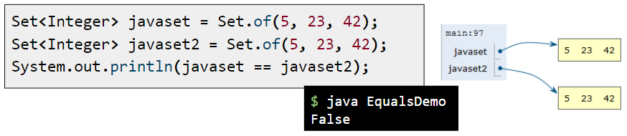

equals(Object o) is a method in the Object that, by default, acts like == in that it checks if the memory address of the this is the same as o. However, we can override it to define equality in whichever way we wish! For example, for two Arraylists to be considered equal, they just need to have the same elements in the same order.

equals() must take an Object argument, in order to override the original .equals() method. It is never true for null. x.equals(null) must be false

### （3）Integer的範圍

public class EqualsTest {

    public static void main(String[] *args*) {

        Integer a = 100;

        Integer b = 100;

        Integer c = 1000;

        Integer d = 1000;

        System.out.println(a==b); // true

        System.out.println(c==d); // false

    }

}

定義一個Integer變量時，會默認進行Integer.valueOf（a）操作，看一下這個方法的源碼（按住ctrl+鼠標左鍵進入該方法），



high的值為127，low的值為-128，當進行這個方法時如果值在-128-127之間，返回的值也就是地址是相同的，所以a和c的地址相同，a==c自然為true

## private constructor總結

### （1）在類外面的實例化

如果一個類的constructor標記為private，則在這個類的外面，無法實例化該類。

例子：

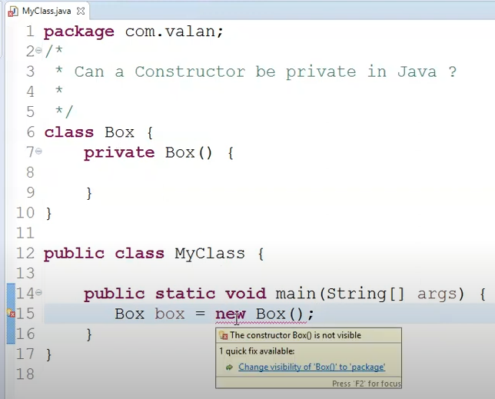

### （2）inner class

如果inner class的constructor標記為private，在outer class裡面，可以自由實例化多個該inner class。

例如：

public class TestPrivateConstructor {

  private static class PrivateInnerClass {

    private int tInt;

    private String tString;

    private PrivateInnerClass(int *i*, String *s*) {

      tInt = i;

      tString = s;

    }

  }

  private PrivateInnerClass sentinel = new PrivateInnerClass(999, "timing");

  public static void main(String[] *args*) {

    TestPrivateConstructor myTest = new TestPrivateConstructor();

    PrivateInnerClass sentinel22 = new PrivateInnerClass(2, "lal");

  }

}

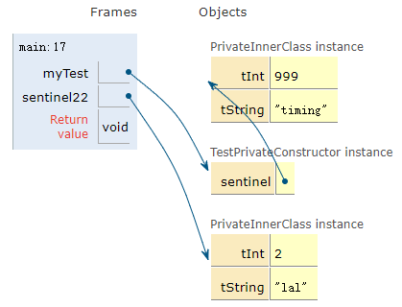

Berkeley CS61B Java

## 1 execute a Java program

The most common way to execute a Java program is to run it through a sequence of two programs. The first is the Java compiler, or javac. The second is the Java interpreter, or java.



For example, to run HelloWorld.java, we'd type the command javac HelloWorld.java into the terminal, followed by the command java HelloWorld. The result would look something like this:



You may notice that we include the '.java' when compiling, but we don't include the '.class' when interpreting. This is just the way it is (TIJTWII).



Try opening up HelloWorld.class using a text editor like Notepad, TextEdit, Sublime, vim, or whatever you like. You'll see lots of crazy garbage that only a Java interpreter could love. This is Java bytecode, which we won't discuss in our course.

## 2 concatenate the elements



The first one of these will succeed; the second will give a compiler error. Since Java is strongly typed, if you tell it h is a string, it can concatenate the elements and give you a string. But when h is an int, it can't concatenate a number and a string and give you a number.

In this case, System.out.println(5 + "horse");, Java interprets the arguments as a string concatentation, and prints out "5horse" as your result. Or, more usefully, System.out.println(5 + " "); will print a space after your "5".

* Expressions also have a type, e.g. “larger(5, 10) + 3” has type int.
* The compiler checks that all the types in your program are compatible **before the program ever runs**!
  + e.g. String x = larger(5, 10) + 3 will fail to compile.
  + This is unlike a language like Python, where type checks are performed DURING execution.

## 3 Defining Functions in Java



A function that is part of a class is called a “method”.

## 4 code description and format

### Comments

Comments where appropriate. Line comments in Java use the // delimiter. Block (a.k.a. multi-line comments) comments use /* and */.

### Style guide

<https://sp19.datastructur.es/materials/guides/style-guide.html>

### Javadoc format

One special note is that all of your methods and almost all of your classes should be described in a comment using the so-called Javadoc format.

<https://en.wikipedia.org/wiki/Javadoc>

## 5 The Enhanced For Loop

Java also supports iteration through an array using an “enhanced for loop”. The basic idea is that there are many circumstances where we don’t actually care about the index at all. In this case, we avoid creating an index variable using a special syntax involving a colon.

For example, in the code below, we do the exact thing as in BreakDemo above. However, in this case, we do not create an index i. Instead, the String s takes on the identity of each String in a exactly once, starting from a[0], all the way up to a[a.length - 1]. You can try out this code at [this link](https://goo.gl/wmhVPM).

public class EnhancedForBreakDemo {

public static void main(String[] args) {

String[] a = {"cat", "dog", "laser horse", "ketchup", "horse", "horbse"};

for (String s : a) {

for (int j = 0; j < 3; j += 1) {

System.out.println(s);

if (s.contains("horse")) {

break;

}

}

}

}

}

上面高亮的部分=下面高亮的部分

public class BreakDemo {

public static void main(String[] args) {

String[] a = {"cat", "dog", "laser horse", "ketchup", "horse", "horbse"};

for (int i = 0; i < a.length; i += 1) {

for (int j = 0; j < 3; j += 1) {

System.out.println(a[i]);

if (a[i].contains("horse")) {

break;

}

}

}

}

}

## 6 Style Guide

Style Guide

Author: Alan Yao

<https://sp21.datastructur.es/materials/guides/style-guide.html>

A note on this style guide: It is probably easier to get to know these rules by running the automated style checker. (More instructions on how to run the automated style checker will be given in the future.)

### Whitespace

1. Each file must end with a newline sequence.
2. Files may not contain horizontal tab characters. Use blanks only for indentation.
3. No line may contain trailing blanks.
4. Do NOT put whitespace:
   1. Around the “<” and “>” within a generic type designation (“List", not "List ", or "List< Integer >").
   2. After the prefix operators “!”, “–”, “++”, unary “-“, or unary “+”.
   3. Before the tokens “;” or the suffix operators “–” and “++”.
   4. After “(“ or before “)”.
   5. After “.”
   6. When you are lonely.
5. DO put whitespace:
   1. After “;”, “,”, or type casts (e.g., “(String) x”, not “(String)x”).
   2. Around binary operators (e.g., “*”, “+”) and comparison operators.
   3. Around assignment operators (e.g., “=”, “+=”).
   4. Around “?” and “:” in the ternary conditional operator (“x>0 ? x : -x”).
   5. Around the keywords “assert”, “catch”, “do”, “else”, “finally”, “for”, “if”, “return”, “synchronized”, “try”, and “while”.
6. In general, break (insert newlines in) lines before an operator, as in

... + 20 * X

+ Y;

1. Do not separate a method name from the “(“ in a method call with blanks. However, you may separate them with a newline followed by blanks (for indentation) on long lines.

### Indentation

1. The basic indentation step is 4 spaces.
2. Indent code by the basic indentation step for each block level (blocks are generally enclosed in “{“ and “}”), as in

if (x > 0) {

r = -x;

} else {

r = x;

}

1. Indent ‘case’ labels an indent past their enclosing ‘switch’, as in

switch (op) {

case '+':

addOpnds(x, y);

break;

default:

ERROR();

}

1. Indent continued lines by the basic indentation step.

### Braces

1. Use { } braces around the statements of all ‘if’, ‘while’, ‘do’, and ‘for’ statements.
2. Place a “}” brace on the same line as a following “else”, “finally”, or “catch”, as in

if (x > 0) {

y = -x;

} else {

y = x;

}

1. Put the “{“ that opens a block at the end of a line. Generally, it goes at the end of the “if”, “for”, “while”, “switch”, “do”, method header, or class header that contains it. If line length forces it to the next line, do not indent it, and put it alone on the line.

### Comments

1. Methods should have javadoc comments explaining the behavior, parameters (using @param tags or otherwise), and return type.
2. Methods that return non-void values must describe them in their Javadoc comment either with a “@return” tag or in a phrase in running text that contains the word “return”, “returning”, or “returns”.
3. Each Javadoc comment must start with a properly formed sentence, starting with a capital letter and ending with a period.

### Names

1. Names of static final constants must be in all capitals (e.g., RED, DEFAULT_NAME).
2. Names of parameters, local variables, and methods must start with a lower-case letter, or consist of a single, upper-case letter.
3. Names of types (classes), including type parameters, must start with a capital letter.
4. Names of packages must start with a lower-case letter.
5. Names of instance variables and non-final class (static) variables must start with either a lower-case letter or “_”.

### Imports

1. Do not use ‘import PACKAGE.’, unless the package is java.lang.Math, java.lang.Double, or org.junit.Assert. ‘import static CLASS.’ is OK.
2. Do not import the same class or static member twice.
3. Do not import classes or members that you do not use.

### Assorted Java Style Conventions

1. Write array types with the “[]” after the element-type name, not after the declarator. Write “String[] names”, not “String names[]”.
2. Write any modifiers for methods, classes, or fields in the following order:
   1. public, protected, or private.
   2. abstract or static.
   3. final, transient, or volatile.
   4. synchronized.
   5. native.
   6. strictfp.
3. Do not explicitly modify methods, fields, or classes where the modification is redundant:
   1. Do not label methods in interfaces or annotations as “public” or “abstract”.
   2. Do not label fields in interfaces or annotations as “static”, “public”, or “final”.
   3. Do not label methods in final classes as “final”.
   4. Do not label nested interfaces “static”.
4. Do not use empty blocks (‘{ }’ with only whitespace or comments inside) for control statements. There is one exception: a catch block may consist solely of comments having the form

/* Ignore EXCEPTIONNAME. */

1. Avoid “magic numbers” in code by giving them symbolic names, as in

public static final MAX_SIZE = 100;

Exceptions are the numerals -10 through 10, 0.5, -0.5, 0.25, -0.25.

1. Do not try to catch the exceptions Exception, RuntimeError, or Error.
2. Write “b” rather than “b == true” and “!b” rather than “b == false”.
3. Replace

if (condition) {

return true;

} else {

return false;

}

with just

return condition;

1. Only static final fields of classes may be public. Other fields must be private or protected.
2. Classes that have only static methods and fields must not have a public (or defaulted) constructor.
3. Classes that have only private constructors must be declared “final”.

### Avoiding Error-Prone Constructs

1. If a class overrides “equals”, it must also override “hashCode”.
2. Local variables and parameters must not shadow field names. The preferred way to handle, e.g., getter/setter methods that simply control a field is to prefix the field name with “_”, as in

public double getWidth() {

return _width;

}

public void setWidth(double width) {

_width = width;

}

1. Do not use nested assignments, such as “if ((x = next()) != null) …”. Although this can be useful in C, it is almost never necessary in Java.
2. Include a “default” case in every “switch” statement.
3. End every arm of a “switch” statement either with a “break” statement or a comment of the form

/* fall through */

1. Do not compare String literals with “==”. Write

if (x.equals("something"))

and not

if (x == "something")

There are cases where you really want to use “==”, but you are unlikely to encounter them in this class.

### Limits

1. No file may be longer than 2000 lines.
2. No line may be longer than 100 characters.
3. No method may be longer than 80 lines.
4. No method may have more than 8 parameters.
5. Every file must contain exactly one outer class (nested classes are OK).

## 7 System.out. printf()

System.out.printf(format, args);

format都要寫在雙引號內

|  |  |
| --- | --- |
| format | 意思 |
| %d | args是整數（十進制） |
| %-8d | args是整數，整個輸出寬度為8個字符，如果args不超過8個字符，則在整個輸出寬度內左對齊 |
| %6d | args是整數，整個輸出寬度為6個字符，如果args不超過6個字符，則在整個輸出寬度內右對齊 |
| %f | args是浮點數 |
| %-9f | args是浮點數，整個輸出寬度為9個字符，如果args不超過9個字符，則在整個輸出寬度內左對齊 |
| %-9.2f | 在上述特征的基礎上，args是精確到小數點後2位的浮點數 |
| %.2f | 不規定輸出寬度，右對齊，浮點數，精確到小數點後2位 |
| %s | args是string |
| %c | args是char |
| %b | args是布爾類型 |
| %% | args是百分比 |
| %n | 換行符 |
| * 同一行內，輸出寬度之間有1個字符的間距 * 同一行內，可以寫多個args，要為每個arg規定相應的format * 如果args寬度超過了字符寬度，則按args寬度來排列 | |

上面的d和f可以換成s（args是String）

public class TestPrintf {

  public static void main(String[] *args*) {

    System.out.printf("%-5d %-3d %-3d %-3d %-3d\n", 999, 99, 99, 99, 99);

    System.out.printf("99999999999999999999\n");

打印結果：（字符之間有間距）

    System.out.printf("%-1d %-1d\n", 999, 99);

System.out.printf("99999999999999999999\n");

打印結果： （args的字符寬度超過了format設置的寬度，按照args的字符寬度排列）

  }

}

## 8 Compile Time VS Run Time

